USING TRACTORS AND PTO EQUIPMENT
Operating tractors and PTO-driven equipment safely to prevent rollover, entanglement, collision and machinery-related injuries.
SOP NUMBER | VERSION | APPROVED BY | NEXT REVIEW | FARM / BUSINESS NAME
SOP-024 | 1.0
📝 Template Note: This Standard Operating Procedure (SOP) is provided as a template only. It must be reviewed and adapted to reflect your farm business.

PURPOSE AND SCOPE
Purpose  To ensure tractors and PTO-driven equipment are operated safely by trained and authorised employees in accordance with manufacturer instructions and farm safety procedures. | Scope  This SOP applies to all employees who operate tractors, attachments or PTO-driven equipment on the farm.
BEFORE YOU START
PPE  Wear close-fitting work clothing, sturdy safety boots and eye protection where required. Hearing protection must be worn when operating an open-cab tractor or where noise levels exceed the applicable exposure standard. Wear high-visibility clothing when working near roads, vehicles or other machinery. | EQUIPMENT  Ensure the tractor, attachment and PTO equipment are suitable for the task. Confirm all guards, shields, securing chains, rollover protection, seat belts and safety devices are fitted and in good condition. | PREPARATION  Only trained, competent and authorised employees may operate a tractor or its attachments. Before starting, complete a walk-around inspection, ensure you are familiar with the controls and manufacturer's instructions, and assess the work area for hazards including people, livestock, powerlines and unstable ground.

! | WARNING: Never approach, step over or work near a rotating PTO shaft. PTO guards cannot completely eliminate the risk of entanglement. Stop the engine, disengage the PTO, remove the key and wait for all moving parts to stop before approaching the equipment.
PROCEDURE
STEP | WHAT TO DO | SAFETY / QUALITY / ENVIRONMENT
1 | Confirm you are authorised and competent  Only operate the tractor if you have been trained, assessed as competent and authorised for that tractor and its attachments. Read the operator’s manual and understand all controls and warning labels. | Do not allow unauthorised people to operate tractors. Some plant activities may require additional licences or competency requirements depending on the equipment and task.
2 | Complete the TCLOC inspection  Check Tyres and Wheels, Cables and Controls, Lights and Electrical, Oils and Fluids, and Chassis. Inspect brakes, steering, hydraulics, three-point linkage, attachments and safety devices. | Do not operate machinery with faults, leaks, damaged tyres or missing guards. Report defects before use.  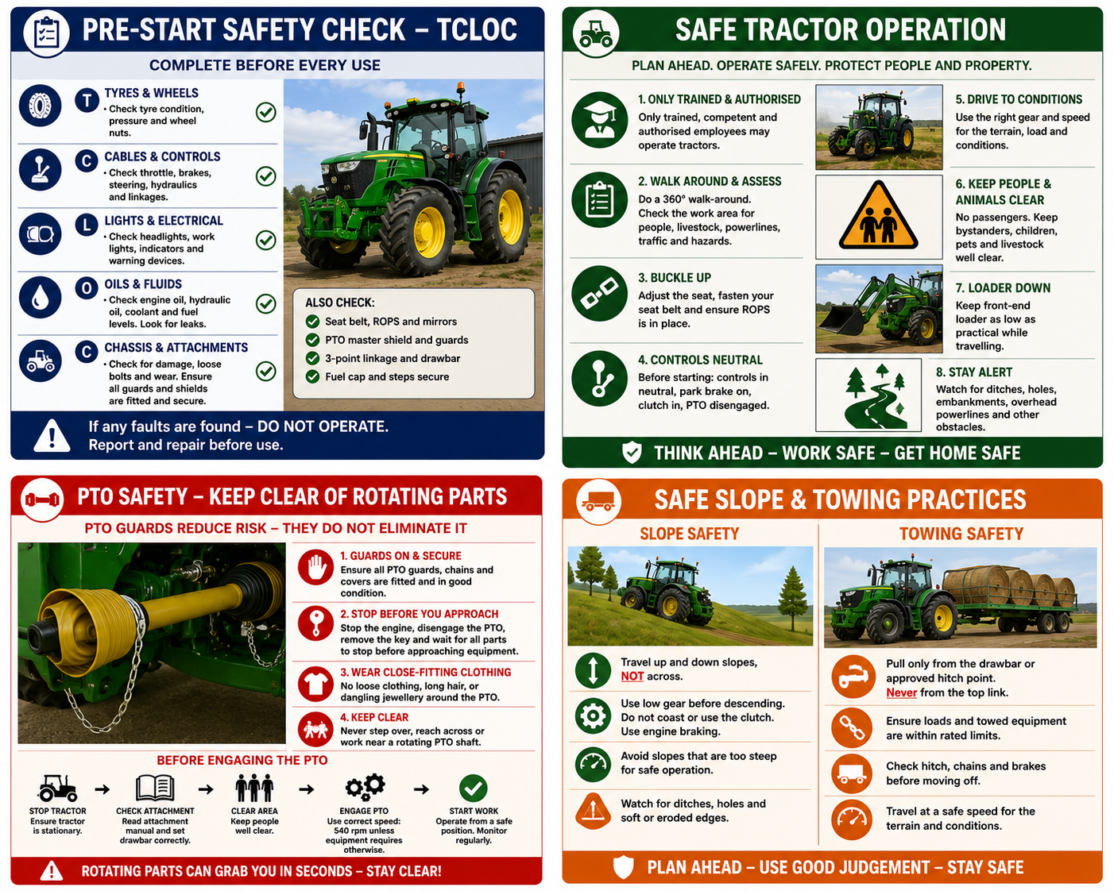
3 | Check protective structures  Inspect the seat belt, Roll Over Protective Structure (ROPS) and Falling Object Protective Structure (FOPS), where fitted. | Wear the seat belt whenever operating a tractor fitted with ROPS. SafeWork NSW advises that tractors between 560 kg and 15,000 kg should have approved rollover protection.
4 | Check PTO guards and attachments  Ensure the PTO master shield, shaft guard, universal joint covers, clutch bell cover and securing chains are fitted and undamaged. Confirm the attachment is compatible with the tractor. | Never use a tractor or PTO attachment with missing, damaged or rotating guards.
5 | Prepare the work area  Remove bystanders, children, pets and livestock from the operating area. Check for powerlines, traffic, holes, ditches, embankments and unstable surfaces. | Avoid work routines involving reversing near people or other vehicles. Maintain safe clearance from overhead powerlines.
6 | Mount and start safely  Use the designated steps and handholds. Adjust the seat, fasten the seat belt and ensure controls are neutral, the parking brake is applied, the clutch is engaged where required and the PTO is disengaged. | Never start the tractor while standing on the ground. Never climb over attachments to access the cab.
7 | Drive to the conditions  Select a suitable gear and speed for the terrain, weather, visibility, load and attachment. Keep the front-end loader as low as practical while travelling. | Avoid sudden turns or braking. Do not operate near ground that may collapse under the tractor’s weight.
8 | Operate on slopes carefully  Avoid slopes that are too steep for safe operation. Select a low gear before descending and use engine braking. Follow the manufacturer’s instructions for travelling on slopes. | Do not coast downhill, depress the clutch or rely only on the brakes. Avoid travelling across steep slopes.  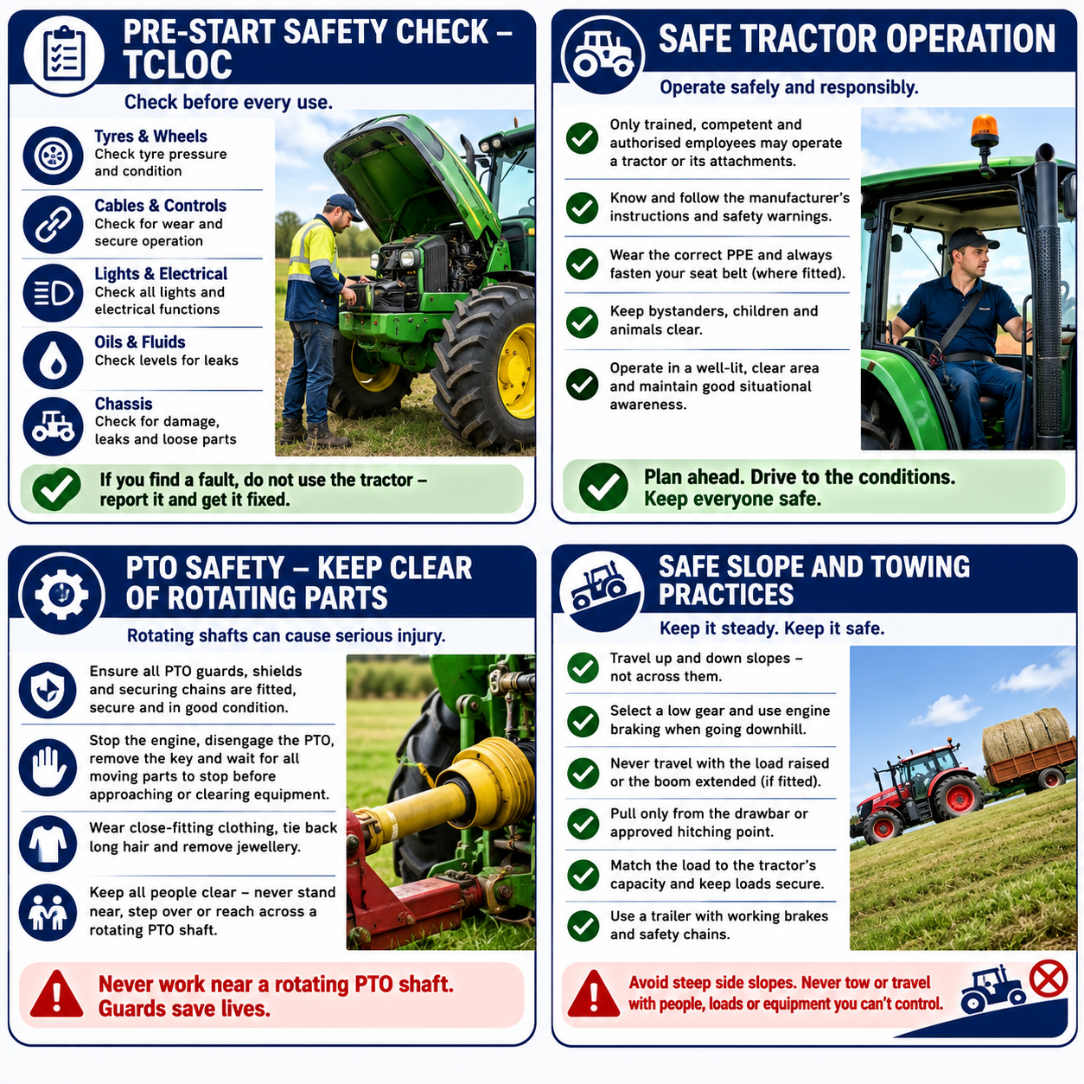
9 | Tow safely  Pull only from the manufacturer-approved drawbar or hitching point. Ensure trailers and implements are correctly attached and within rated limits. | Never tow from the top link or above the approved hitching point because this may cause the tractor to overturn backwards.
10 | Protect people and animals  Maintain awareness of workers, livestock, vehicles and structures throughout the task. | Do not carry passengers on the tractor, attachments or towed equipment unless a manufacturer-approved passenger seat is provided.
11 | Prepare PTO equipment  Read the attachment instructions and ensure the tractor drawbar is adjusted as specified. Check the PTO shaft will not contact the drawbar or other components when raised, lowered or turning. | Wear close-fitting clothing, tie back long hair and remove dangling jewellery.
12 | Engage the PTO safely  Stop tractor movement before engaging the PTO. Select the PTO speed specified by the manufacturer - normally 540 rpm unless the equipment is designed for another speed. | Keep all people clear before engaging the PTO. Never exceed the equipment’s rated speed.
13 | Operate stationary PTO equipment  Park on firm, level ground, apply the parking brake and chock the wheels where required. Monitor the equipment from a safe position. | Never stand beside, step over or reach toward a rotating PTO shaft, even when guarded.
14 | Clear blockages safely  Disengage the PTO, lower the attachment, stop the engine, remove the key and wait until all moving parts have completely stopped before inspecting or clearing equipment. | Never use hands or feet to clear operating machinery. Use suitable tools once all energy sources are isolated.
15 | Travel on public roads  Confirm the tractor is registered where required and the operator holds the appropriate driver licence. Check lights, indicators, brakes and the amber beacon before entering a public road. | Lock independent brakes together for road travel and travel at a safe speed for traffic and conditions.
16 | Shut down safely  Park on level ground, disengage the PTO, lower all attachments, place controls in neutral, apply the parking brake, stop the engine and remove the key. | Ensure the tractor and attachments have completely stopped before dismounting.
17 | Clean and inspect after use  Remove mud, grass and debris from the tractor, engine area, attachments and PTO equipment. Inspect for damage and report faults. | Isolate unsafe machinery until repairs are completed. Keep the tractor clean so leaks and defects can be identified.
NEVER
- Operate a tractor without training and authorisation.
- Start the engine while standing on the ground.
- Carry passengers unless an approved passenger seat is provided.
- Operate without the seat belt where ROPS is fitted.
- Use attachments or PTO equipment with missing or damaged guards.
- Stand near, step over or reach across a rotating PTO shaft.
- Clear a blockage while the tractor or PTO is operating.
- Pull from the top link or an unapproved hitching point.
- Operate close to unstable embankments, ditches or overhead powerlines.
- Leave the tractor unattended with the engine running or attachments raised.
SPILLS, EXPOSURE AND EMERGENCIES
! | EMERGENCY: If a rollover, entanglement, collision or machinery failure occurs, stop work immediately and contact emergency services where required. Do not approach moving machinery until it has been isolated and all movement has stopped. Provide first aid if safe to do so, notify the farm manager and preserve the incident area where required.
DISPOSAL AND ENVIRONMENTAL PROTECTION
Clean and Disposal | Remove accumulated grass, manure and debris to reduce fire risk and assist with maintenance inspections. Clean up fuel, oil and hydraulic leaks promptly and dispose of contaminated materials in accordance with the farm’s environmental procedures.
FARM-SPECIFIC DETAILS
! | IMPORTANT: Complete these details before this SOP is issued to workers.
Authorised operators
Parking/Storage location
Tractor attachments
Fuel storage location
Maintenance records
Emergency contact / farm manager

Disclaimer
Dairy Australia provides this template as general guidance only. Farm businesses are responsible for reviewing, customising and implementing this SOP to suit their own workplace, equipment, hazards and legal obligations. Users should ensure this SOP reflects current legislation, manufacturer instructions, product labels and Safety Data Sheets (SDS) relevant to their business.

ATTACHMENTS

- HAY TRAILER AND BALE HANDLING
- POST HOLE DIGGER
- ROTARY SLASHER
- SILAGE AND HAY OPERATIONS

A. HAY TRAILER AND BALE HANDLING
Safely loading, transporting and feeding out hay and silage bales using a tractor and trailer.
PURPOSE AND SCOPE
Purpose  To ensure hay and silage bales are loaded, transported and fed out safely while minimising the risk of injury, equipment damage and livestock hazards. |  |  | Before you start  Ensure SOP-024 – Using Tractors & PTO Equipment has been completed.  Inspect the trailer, forks and attachment points.  Confirm the work area is clear of people, livestock and vehicles.  Plan the route before moving bales.
 | ! | WARNING: Large hay bales can shift or fall unexpectedly. Always carry bales low to the ground and never allow people near suspended loads.
PROCEDURE
STEP | WHAT TO DO | SAFETY / QUALITY / ENVIRONMENT
1 | Load the trailer  Load one bale at a time. Spear the bale through the centre and carry it low until close to the trailer before raising it into position. | Keep forks slightly tilted upward while transporting the bale.
2 | Load correctly  Position square bales with the face of the bale facing outward. | Correct orientation makes feeding out easier and safer.  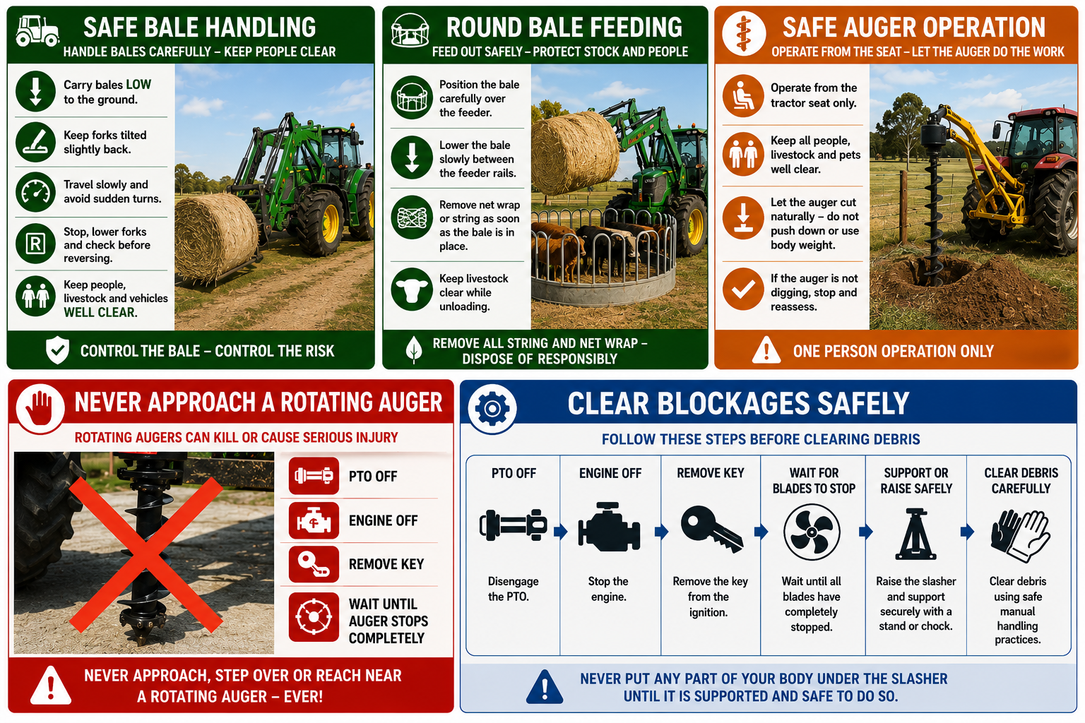
3 | Feed out hay  Position the bale carefully over the feeder before lowering it into place. | Ensure forks are lowered between the feeder rails without striking the feeder.
4 | Remove string or net wrap  Park safely before leaving the tractor. Remove bale strings or net wrap and dispose of them appropriately. | Place the tractor in neutral, apply the park brake and remove string immediately to prevent livestock ingestion.
5 | Move hay rings  Fold hay rings where applicable before lifting and relocating them. | Ensure no people or livestock are nearby and drive to the ground conditions.
NEVER
- Carry bales high while travelling.
- Turn sharply with raised forks.
- Leave string or net wrap in paddocks.
- Allow people or livestock near suspended bales.

B. POST HOLE DIGGER
Operating a tractor-mounted post hole digger safely while preventing entanglement and crushing injuries.
PURPOSE AND SCOPE
Purpose  To ensure post hole digging is completed safely while preventing contact with moving parts, underground services and rotating equipment. |  |  | Before you start  Ensure SOP-024 – Using Tractors & PTO Equipment has been completed.  Confirm all PTO guards are fitted.  Inspect auger, pins, bolts and hydraulic hoses.  Confirm the attachment is securely connected.  Check for underground services before digging.
 | ! | WARNING: Never approach or attempt to free a rotating auger. Stop the engine, disengage the PTO and wait until all movement has stopped before approaching the machine.
PROCEDURE
STEP | WHAT TO DO | SAFETY / QUALITY / ENVIRONMENT
1 | Inspect the equipment  Check guards, PTO shields, auger condition and all attachment points. | Do not operate with damaged or missing guards.
2 | Prepare the work area  Remove stones, wire and debris and confirm underground services have been identified. | Ensure bystanders and livestock remain clear.
3 | Dig safely  Operate from the tractor seat and allow the auger to cut naturally. | Never push down on the auger or stand near rotating components.
4 | Clear blockages  Stop the tractor, disengage the PTO and remove the key before clearing any blockage. | Never attempt to free the auger while connected to the PTO.
5 | Shut down  Wait until the auger has completely stopped before leaving the tractor and store the attachment securely. | Prevent the attachment from falling when disconnected.
NEVER
- Stand near a rotating auger.
- Operate without guards.
- Free a jam while the PTO is engaged.
- Put body weight on the auger.
- Dig before checking for underground services.

C. ROTARY SLASHER
Operating tractor-mounted rotary slashers safely while controlling flying debris and PTO hazards.
PURPOSE AND SCOPE
Purpose  To ensure rotary slashing is completed safely while protecting operators, bystanders and equipment from moving blades and flying debris. |  |  | Before you start  Ensure SOP-024 – Using Tractors & PTO Equipment has been completed.  Inspect blades, guards, debris chains and PTO guards.  Confirm the slasher is securely attached.  Ensure the work area is clear of people, livestock and vehicles.
 | ! | WARNING: Rotary slashers can throw rocks, sticks and other debris at high speed. Never operate while people, livestock or vehicles are within the work area.
PROCEDURE
STEP | WHAT TO DO | SAFETY / QUALITY / ENVIRONMENT
1 | Load the slasher  Check blades, fasteners, debris chains, guards and PTO covers before use. | Do not operate with damaged guards or worn blades.
2 | Prepare the work area  Ensure the area is clear of people, livestock and vehicles before engaging the PTO. | Flying debris may still occur even when guards are fitted.
3 | Operate the slasher  Engage the PTO at the recommended speed and maintain clear visibility while slashing. | Stop work immediately if anyone enters the work area.  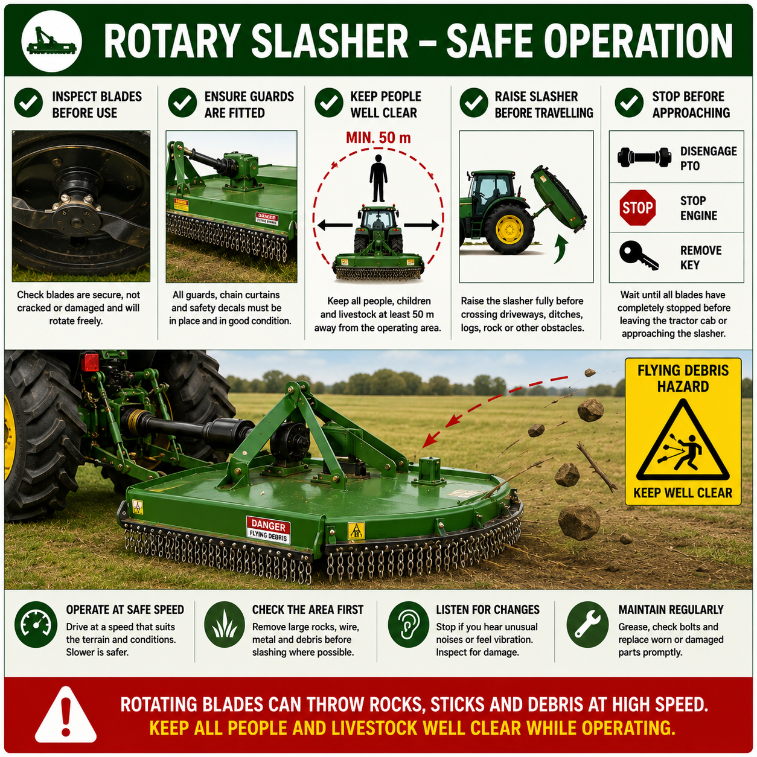
4 | Clear blockages safely  Raise the slasher, stop the engine, disengage the PTO and support the slasher securely before working underneath. | Wait until blades have completely stopped before approaching the machine.
5 | Clean after use  Remove grass and debris from the slasher, PTO and guards before storage. | Regular cleaning reduces fire risk and helps identify maintenance issues.
NEVER
- Operate with damaged guards or debris chains.
- Allow people near the slasher while operating.
- Reach beneath the slasher until blades have stopped.
- Clean or service the slasher while the PTO is engaged.
- Leave accumulated grass or debris on the machine.

D. SILAGE AND HAY OPERATIONS
Safely operating tractor-mounted mowing, tedding and raking equipment to produce high-quality silage and hay.
PURPOSE AND SCOPE
Purpose  To ensure mowing, tedding and raking equipment is operated safely and efficiently while maintaining machinery performance and producing high-quality forage. |  |  | Before you start  Ensure SOP-024 – Using Tractors & PTO Equipment has been completed.  Inspect all PTO shafts, guards, hydraulic hoses and attachments.  Complete all seasonal servicing and lubrication.  Check blades, tynes, bearings and tyres are in good condition.  Ensure the work area is clear of people, livestock and obstacles.
 | ! | WARNING: Never approach the implement while the PTO is engaged or any moving parts are still rotating. Always disengage the PTO, stop the engine, remove the key and wait until all movement has completely stopped before inspecting, clearing blockages or carrying out maintenance. Keep all people well clear of the operating area, as blades and rotors can throw rocks and other debris at high speed.
PROCEDURE
STEP | WHAT TO DO | SAFETY / QUALITY / ENVIRONMENT
1 | Complete pre-season checks  Before the season begins, inspect and service the mower, tedder and rake in accordance with the manufacturer's recommendations. Grease all lubrication points, inspect hydraulic hoses, PTO components, bearings, tyres, blades, tynes and conditioning components, and repair or replace worn or damaged parts. | Well-maintained equipment improves reliability, reduces downtime and produces a higher quality harvest.
2 | Prepare the equipment  Connect the implement securely, ensure all PTO guards and hydraulic connections are fitted correctly and check that the attachment is adjusted for the paddock conditions and crop. | Confirm all guards are in place before operating. Do not use damaged or unguarded equipment.
3 | Inspect the work area  Walk or visually inspect the paddock for rocks, wire, branches, fence posts, power poles, trees and other hazards. Ensure people, livestock and vehicles are clear before unfolding or operating equipment. | Folding implements and rotating components create significant crush and strike hazards.
4 | Operate the mower conditioner  Set the cutting height to suit the crop and terrain. Engage the PTO at the recommended speed and monitor the cut quality throughout operation. Regularly inspect blades and conditioning rollers or fingers for wear or damage. | Stop immediately if unusual vibration, noise or poor cutting performance is observed. Sharp blades and correct conditioning improve drying and forage quality.  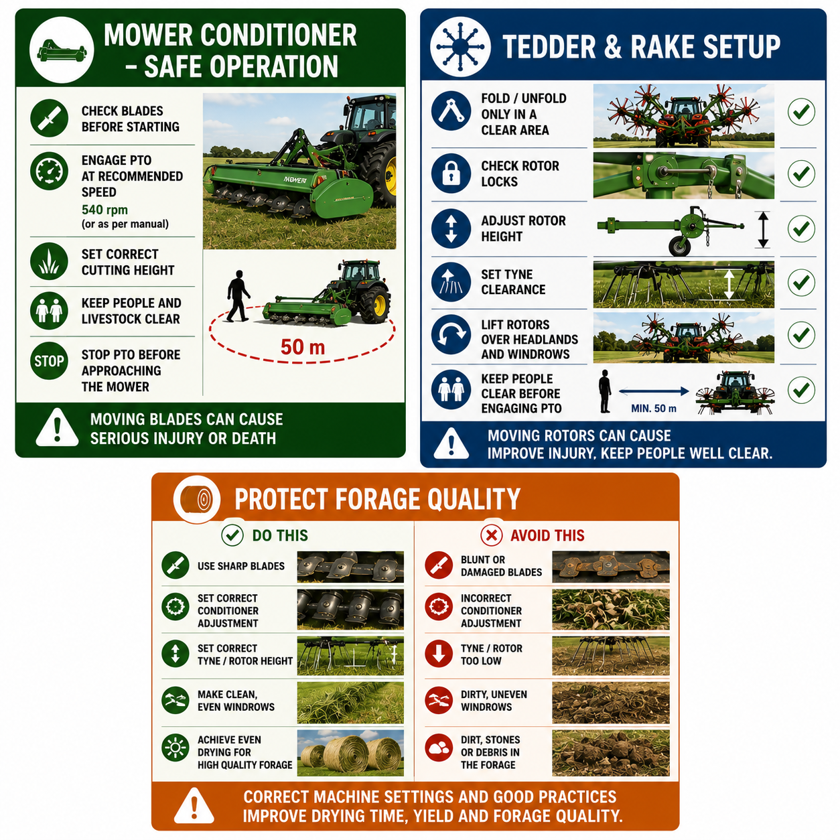
5 | Operate the tedder  Unfold the machine in a clear area and ensure transport locks are fully released. Adjust rotor angle, wheel height and tyne clearance to suit crop density and terrain. Ted the crop evenly while avoiding unnecessary tight turns. | Correct machine adjustment promotes even drying and reduces crop losses. Keep people clear while folding, unfolding and operating the tedder.
6 | Operate the rotary rake  Lower the rotor arms, set the rotor height and adjust tyne clearance to produce clean, even windrows. Lift the rotors over headlands and windrows when turning. | Avoid running the tynes into the ground, as this can introduce soil contamination into the forage and damage equipment.
7 | Monitor quality throughout harvesting  Regularly observe the crop behind the machine to ensure mowing, tedding and raking are producing the desired result. Adjust machine settings where necessary to suit changing crop and paddock conditions. | Correct machine setup improves drying time, forage quality and overall harvest yield.
8 | Shut down and clean equipment  Disengage the PTO, stop the engine, remove the key and wait until all moving parts have stopped before leaving the tractor. Remove accumulated grass and debris, inspect the implement for damage and report any maintenance requirements. | Cleaning machinery reduces fire risk, assists maintenance inspections and prepares the equipment for its next use.
NEVER
- Operate with damaged or missing PTO guards.
- Approach the implement until all moving parts have completely stopped.
- Fold or unfold implements while people, livestock or vehicles are nearby.
- Operate machinery with damaged blades, tynes, bearings or hydraulic components.
- Allow mower blades, tedders or rake rotors to strike rocks, fences or other obstacles.
- Leave the tractor before disengaging the PTO, stopping the engine and removing the key.
- Ignore unusual vibration, excessive noise or poor machine performance.
- Continue harvesting if machine settings are producing poor-quality forage or contaminating the crop with soil or debris.

