USING A TELEHANDLER
Operating telehandlers safely to reduce the risk of injury, collisions, overturning and dropped loads.
SOP NUMBER | VERSION | APPROVED BY | NEXT REVIEW | FARM / BUSINESS NAME
SOP-023 | 1.0
📝 Template Note: This Standard Operating Procedure (SOP) is provided as a template only. It must be reviewed and adapted to reflect your farm business.

PURPOSE AND SCOPE
Purpose  To ensure telehandlers are operated safely and efficiently by trained and competent employees in accordance with manufacturer recommendations, workplace health and safety requirements, and farm procedures. | Scope  This SOP applies to all employees authorised to operate telehandlers on the farm
BEFORE YOU START
PPE  Wear suitable work clothing, enclosed safety boots, eye protection where required and hearing protection when operating machines without enclosed cabs or where noise levels exceed exposure standards. Wear high-visibility clothing when working around other vehicles and carry a suitable communication device when working alone. | EQUIPMENT  Ensure the telehandler is suitable for the task and fitted with all required guards and safety devices. Have the manufacturer's operating manual available and ensure the correct attachment is fitted securely before use. | PREPARATION  Only trained, competent and authorised operators may use a telehandler. Before commencing work, complete the manufacturer's pre-start inspection, review the work area for hazards including overhead powerlines, traffic and pedestrians, and ensure all required attachments are correctly fitted and rated for the task. Operators must be familiar with the machine's controls, load chart and safe operating procedures before use.

! | WARNING: Telehandlers can overturn or drop loads if operated outside the manufacturer's limits. Never exceed the rated lifting capacity or lift loads over people. Always wear the seat belt while operating the machine.
PROCEDURE
STEP | WHAT TO DO | SAFETY / QUALITY / ENVIRONMENT
1 | Confirm you are authorised and competent  Only operate the telehandler if you have received appropriate training, been assessed as competent and have been authorised by your employer. | Operators must be competent under applicable WHS legislation. Never use a work platform attachment unless all legal requirements have been met. Some telehandler applications or jurisdictions require additional licences or qualifications.
2 | Complete pre-start inspection  Read the operator's manual if unfamiliar with the machine and complete the manufacturer's daily inspection. Check tyres, steering, brakes, hydraulics, lights, attachments, guards, warning devices, seat belt and fluid levels.. | Do not operate the machine if faults are identified. Report defects immediately.  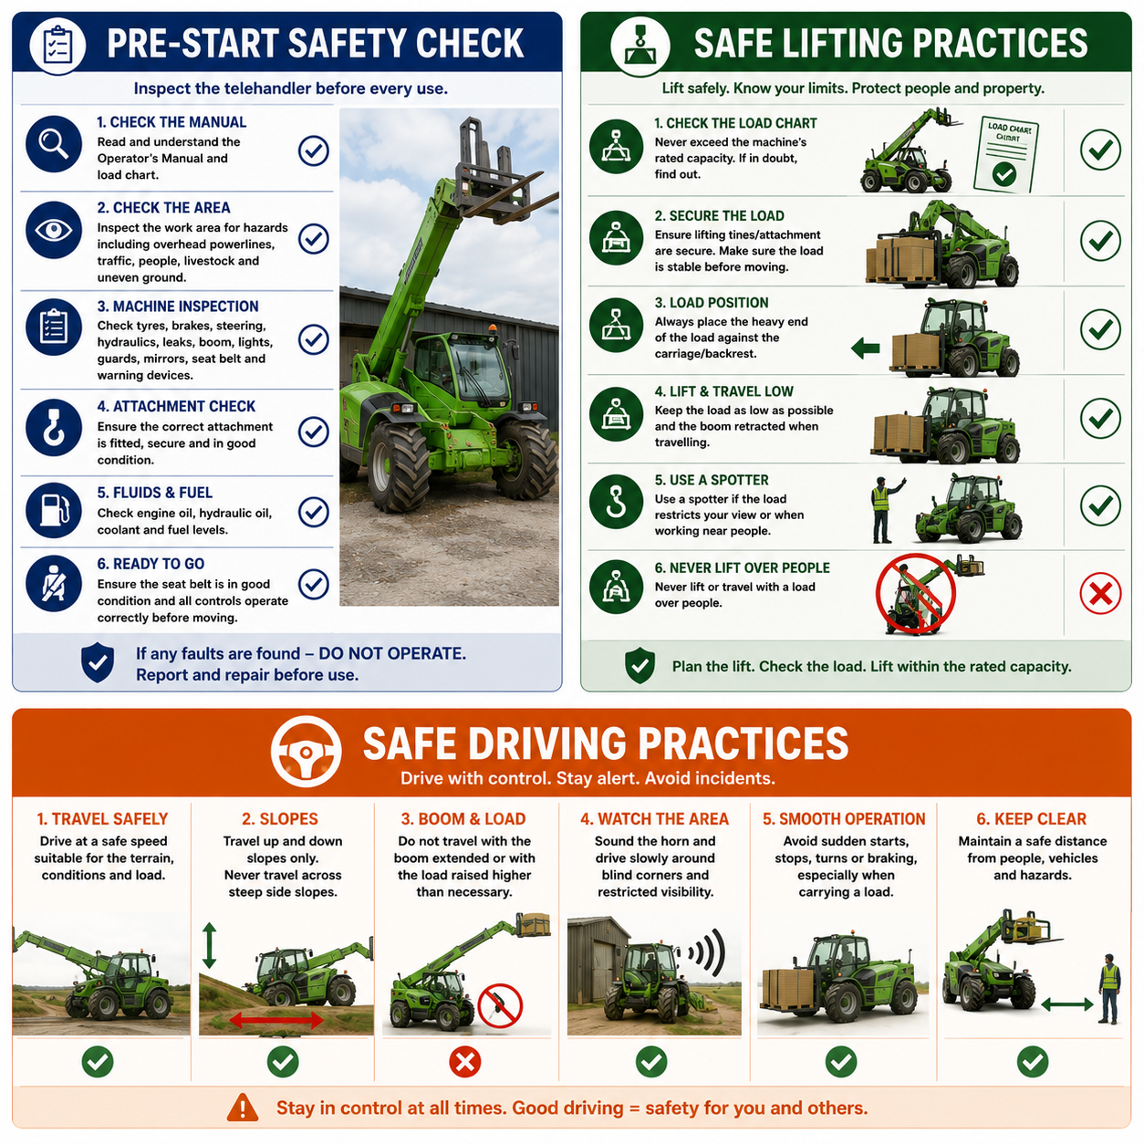
3 | Inspect the work area  Identify hazards including overhead powerlines, underground services, traffic, livestock, pedestrians, uneven ground and restricted visibility. | Keep unauthorised people clear of the work area and avoid unnecessary reversing.
4 | Prepare for operation  Adjust the seat and mirrors, fasten the seat belt and confirm all controls operate correctly before moving. Familiarise yourself with the machine dimensions and attachment reach. | Never operate without wearing the seat belt.
5 | Lift loads safely  Confirm the load weight is within the load chart, secure the attachment, keep the heavy end of the load against the carriage and travel with the load low and the boom retracted wherever possible. | Never exceed the rated capacity or travel with the boom extended unless necessary for the task.
6 | Travel safely  Drive at a safe speed suitable for the terrain and load. Travel up and down slopes rather than across them and use extra caution on wet or uneven surfaces. Sound the horn when approaching blind corners. | Never travel across steep side slopes or with an elevated load that restricts vision. Use a spotter if visibility is limited.
7 | Protect yourself and others  Maintain exclusion zones around the telehandler. Never allow passengers and never lift loads over people. | Only lift people using an approved work platform where permitted and all legal training, equipment and licensing requirements have been met.
8 | Refuel and park safely  Park on level ground, lower the boom and attachment to the ground, apply the parking brake, place the transmission in park, stop the engine and remove the key. Allow the machine to cool before refuelling. | Never smoke while refuelling and never leave the machine unattended while running.
9 | Clean and inspect after use  Remove mud, crop residue and debris, inspect for damage and report any faults before storing the machine. | Store the telehandler in a clean, designated area ready for the next operator.
NEVER
- Operate a telehandler without training and authorisation.
- Exceed the machine's rated lifting capacity.
- Lift or travel with people unless using an approved work platform and all legal requirements have been met.
- Lift loads over people.
- Travel with the load raised higher than necessary.
- Travel across steep side slopes.
- Operate near overhead powerlines unless safe clearances can be maintained.
- Leave the machine unattended with the boom raised or the engine running.
SPILLS, EXPOSURE AND EMERGENCIES
! | EMERGENCY: If the telehandler becomes unstable, a load shifts or an incident occurs, stop the machine immediately if it is safe to do so. Lower the load where possible, isolate the machine, provide first aid if required, contact emergency services where necessary and report the incident to your supervisor. Do not use the telehandler again until it has been inspected and declared safe.
DISPOSAL AND ENVIRONMENTAL PROTECTION
Disposal | Remove mud, straw and debris from the machine after use to reduce fire risk and assist inspections. Clean up any fuel or hydraulic oil spills immediately and dispose of waste materials in accordance with the farm's environmental procedures.
FARM-SPECIFIC DETAILS
! | IMPORTANT: Complete these details before this SOP is issued to workers.
Authorised operators
Parking location
Fuel storage location
Maintenance records
Emergency contact / farm manager

Disclaimer
Dairy Australia provides this template as general guidance only. Farm businesses are responsible for reviewing, customising and implementing this SOP to suit their own workplace, equipment, hazards and legal obligations. Users should ensure this SOP reflects current legislation, manufacturer instructions, product labels and Safety Data Sheets (SDS) relevant to their business.

