USING TWO-WHEEL MOTORBIKES
Operating two-wheel motorbikes safely to reduce the risk of injury, loss of control and equipment damage.
SOP NUMBER | VERSION | APPROVED BY | NEXT REVIEW | FARM / BUSINESS NAME
SOP-022 | 1.0
📝 Template Note: This Standard Operating Procedure (SOP) is provided as a template only. It must be reviewed and adapted to reflect your farm business.

PURPOSE AND SCOPE
Purpose  To ensure two-wheel motorbikes are operated safely by trained and authorised employees while undertaking farm activities. | Scope  This SOP applies to all employees authorised to operate two-wheel motorbikes on the farm.
BEFORE YOU START
PPE  Wear an approved AS 1698 motorcycle helmet with the chin strap securely fastened, sturdy boots with good tread, long pants and abrasion-resistant clothing suitable for the weather conditions. | EQUIPMENT  Ensure the motorbike is suitable for the task and has sufficient fuel. Carry a suitable communication device where working alone or remotely. | PREPARATION  Only trained and authorised employees may operate a motorbike. Before riding, complete the TCLOC pre-start inspection, ensure the motorbike is mechanically sound, familiarise yourself with all controls and warning labels, and advise someone where you will be working and your expected return time. | TIP  Smooth acceleration, braking and steering will improve stability, particularly on slippery or uneven ground.

! | WARNING: Never operate a motorbike without wearing a correctly fitted and secured approved helmet. Do not ride a motorbike that has mechanical faults or unsafe tyres, brakes or controls.
PROCEDURE
STEP | WHAT TO DO | SAFETY / QUALITY / ENVIRONMENT
1 | Confirm you are authorised and competent  Only operate the vehicle if you have been trained, inducted and authorised. Familiarise yourself with the manufacturer's instructions, controls and warning labels. | Training records should be maintained, and operators should understand the manufacturer's recommendations before use.
2 | Complete the TCLOC pre-start inspection  Check Tyres and Wheels, Cables and Controls, Lights and Electrical, Oils and Fluids, and Chassis and Suspension before each use. Remove mud or debris to assist with the inspection. | Correct tyre pressure and tyre condition are essential for safe handling and braking. Do not ride if faults are identified.  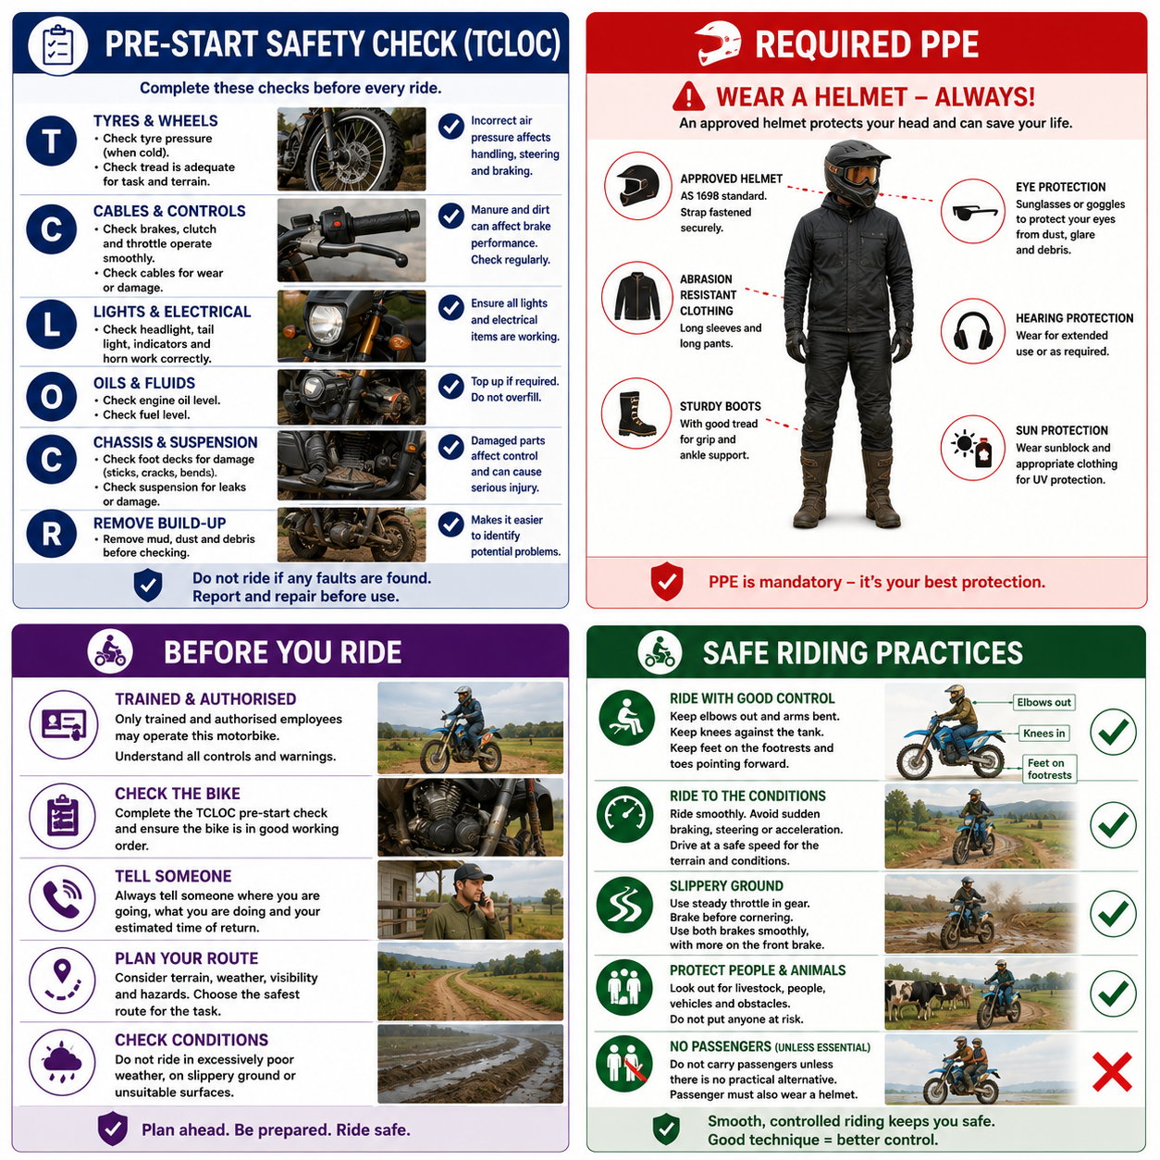
3 | Prepare for operation  Start the motorbike and check the front and rear brakes, throttle, clutch and controls operate smoothly. Ensure you can comfortably reach and operate all controls and confirm your helmet is securely fastened. | If any component is not functioning correctly, stop using the motorbike and report the fault.
4 | Ride using correct body position  Keep both feet on the footrests while moving, toes pointed forward, knees against the fuel tank and elbows slightly bent to assist with balance and control. | Correct riding position improves stability and reduces the risk of losing control.
5 | Ride to the conditions  Travel at a safe speed for the terrain, visibility and weather conditions. Ride smoothly, avoid sudden braking or acceleration and take wide turns where appropriate. | Be alert for rocks, irrigation pipes, branches, wires, race tape and other hazards. Slow down around the dairy, silage stack and other high-traffic areas.
6 | Ride safely on slippery ground  Maintain steady throttle control, brake progressively using both brakes, complete braking before entering corners and avoid sudden steering inputs. | Riding smoothly improves traction and reduces the risk of skidding.
7 | Protect yourself and others  Do not carry passengers unless there is no practical alternative, and ensure any passenger also wears an approved helmet. | Ensure no people or animals are endangered while operating the motorbike.  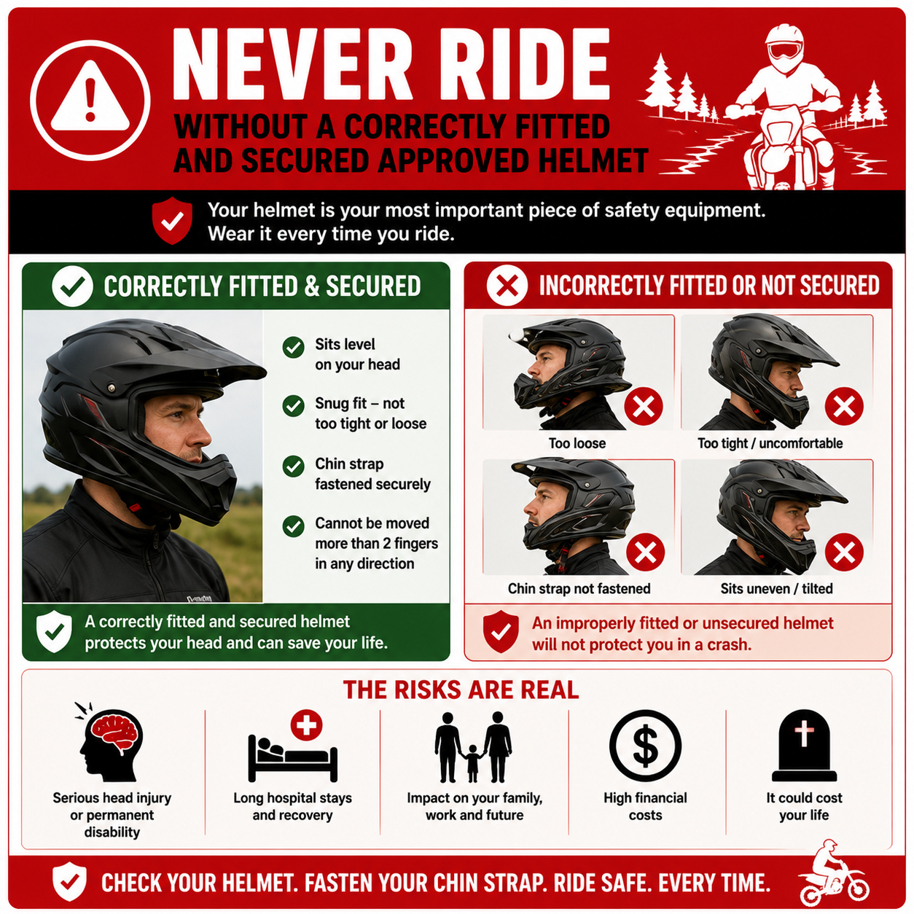
8 | After use  Park on firm, level ground, ensure the stand is stable, allow the motorbike to cool before refueling and never smoke while refueling. Refuel before returning the bike to the shed where required. Wash excessive mud from the motorbike, inspect for damage or mechanical faults and report any defects. | Never leave the vehicle unattended while running.
NEVER
- Ride without an approved helmet.
- Ride a motorbike with faulty brakes, tyres or controls.
- Carry passengers unless absolutely necessary.
- Ride faster than conditions allow.
- Remove your feet from the footrests while riding.
- Ride on public roads unless both you and the motorbike meet all legal requirements.
- Smoke while refuelling.
- Ignore mechanical faults or warning signs.
SPILLS, EXPOSURE AND EMERGENCIES
! | EMERGENCY: If an incident or mechanical failure occurs, stop the motorbike immediately, move to a safe location, if possible, provide first aid where required, contact emergency services if necessary and notify your supervisor. Do not operate the motorbike again until faults have been repaired.
DISPOSAL AND ENVIRONMENTAL PROTECTION
Disposal | Remove mud and debris after use to assist with inspections and prolong equipment life. Clean up any fuel or oil spills immediately and dispose of waste materials in accordance with the farm's environmental procedures.
FARM-SPECIFIC DETAILS
! | IMPORTANT: Complete these details before this SOP is issued to workers.
Authorised operators
Parking location
Farm speed limit
Fuel storage location
Maintenance records
Emergency contact / farm manager

Disclaimer
Dairy Australia provides this template as general guidance only. Farm businesses are responsible for reviewing, customising and implementing this SOP to suit their own workplace, equipment, hazards and legal obligations. Users should ensure this SOP reflects current legislation, manufacturer instructions, product labels and Safety Data Sheets (SDS) relevant to their business.

