USING SIDE-BY-SIDE VEHICLES
Operating side-by-side vehicles safely to reduce the risk of injury, rollover and equipment damage.
SOP NUMBER | VERSION | APPROVED BY | NEXT REVIEW | FARM / BUSINESS NAME
SOP-021 | 1.0
📝 Template Note: This Standard Operating Procedure (SOP) is provided as a template only. It must be reviewed and adapted to reflect your farm business.

PURPOSE AND SCOPE
Purpose  To ensure side-by-side vehicles are operated by trained and authorised employees in accordance with manufacturer recommendations and farm safety procedures. | Scope  This SOP applies to all employees who operate side-by-side vehicles on the farm.
BEFORE YOU START
PPE  Wear suitable work clothing, sturdy enclosed footwear and sun protection. Wear hearing protection where required and consider wearing an approved helmet if recommended by the manufacturer or where a risk assessment identifies the need. | EQUIPMENT  Ensure the side-by-side vehicle is suitable for the task and fitted with a functioning rollover protective structure (ROPS), seat belts, doors or retention systems, and all required guards. Carry a suitable communication device when working alone or remotely. | PREPARATION  Only trained and authorised employees may operate a side-by-side vehicle. Before use, complete all pre-start checks, ensure the vehicle is mechanically sound, confirm loads are suitable and secure, and advise someone where you will be working and your expected return time. | TIP  Before each trip, plan your route, assess the terrain and select a safe speed for the conditions.

! | WARNING: Always wear your seat belt and keep doors or occupant restraints secured while the vehicle is moving. Never operate a side-by-side vehicle with damaged seat belts, faulty safety equipment or missing rollover protection.
PROCEDURE
STEP | WHAT TO DO | SAFETY / QUALITY / ENVIRONMENT
1 | Confirm you are authorised and competent  Only operate the vehicle if you have been trained, inducted and authorised. Familiarise yourself with the manufacturer's instructions, controls and warning labels. | Training records should be maintained and operators should understand the manufacturer's recommendations before use.
2 | Complete the pre-start inspection  Check tyres, steering, brakes, lights, fluid levels, guards, ROPS, seat belts, doors or retention systems and parking brake before starting. | Do not operate the vehicle if any safety component is damaged or faulty.  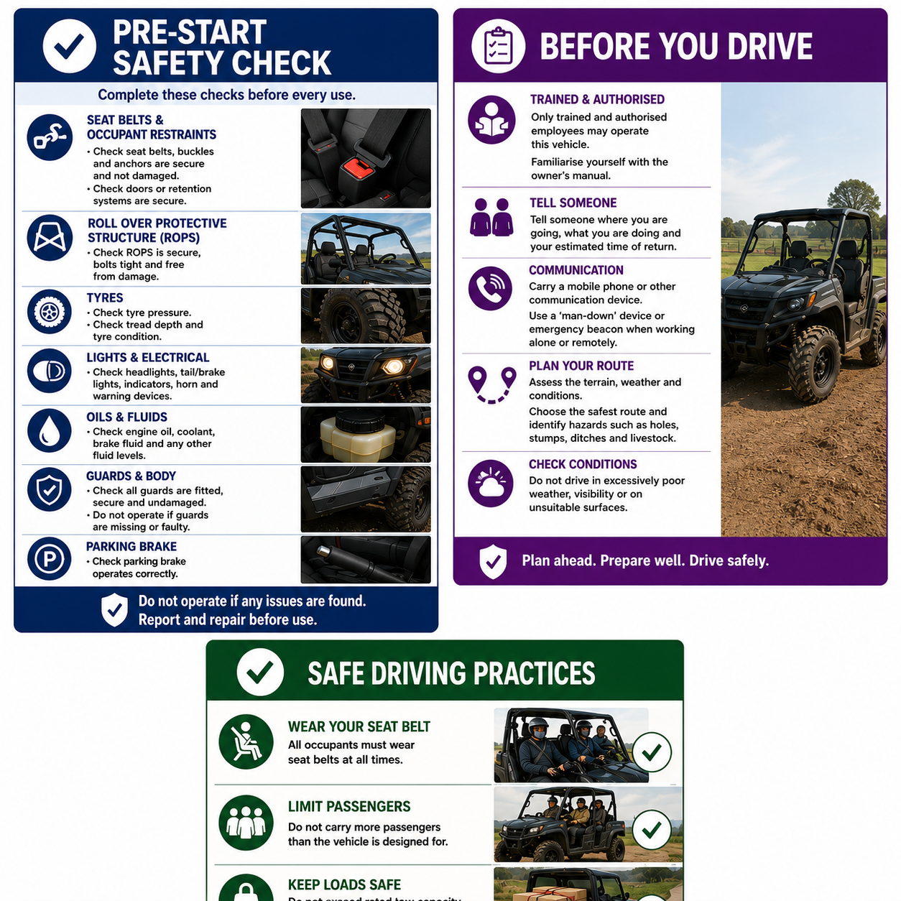
3 | Prepare for operation  Ensure the transmission is in neutral or park, the parking brake is applied and all controls operate correctly before starting the engine. | Never start or operate controls from anywhere other than the driver's seat.
4 | Secure occupants and loads  Ensure every occupant is seated correctly and wearing a seat belt. Do not exceed the manufacturer's passenger or load capacity. Secure all loads and keep the centre of gravity as low as possible. | Loads must not shift during travel. Use only accessories and implements approved by the manufacturer.
5 | Tow safely  Only tow within the manufacturer's rated towing capacity and always use the designated drawbar or tow point. | Exceeding towing limits can reduce braking performance and vehicle stability.
6 | Drive safely  Select the safest route, observe farm speed limits and drive at a speed appropriate to the terrain and conditions. Remain alert for holes, stumps, livestock, people and other hazards. | Maintain control of the vehicle at all times and ensure no person or animal is endangered.  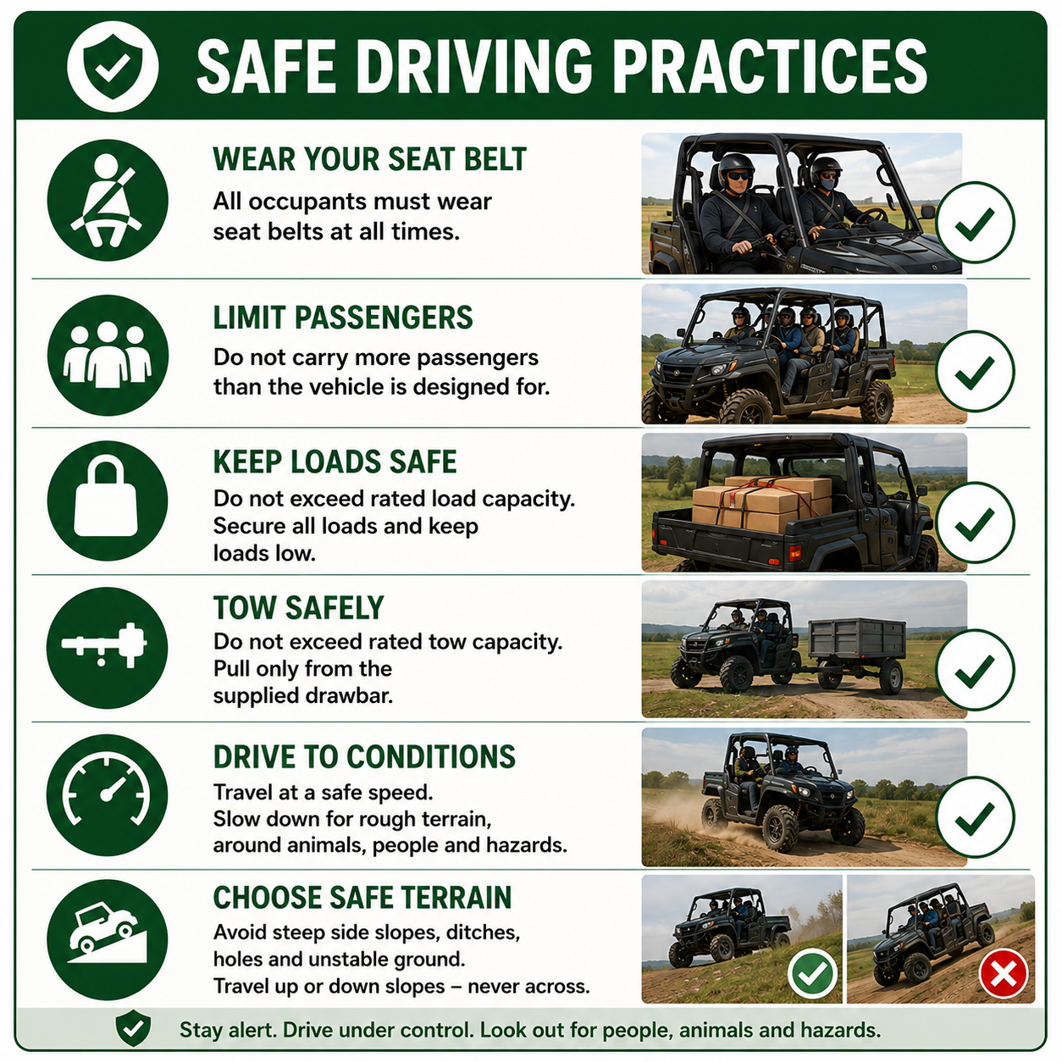
7 | Maintain communication  Carry a mobile phone or other suitable communication device when working alone. Tell someone where you are going and when you expect to return. | Agree on what action will be taken if you do not return as expected. Consider a man-down device or emergency beacon where working remotely or outside mobile coverage.
8 | After use  Park on level ground, engage the parking brake, place the transmission in park, switch off the engine and remove the key. Remove mud and debris, inspect the quad bike for damage, report faults and store PPE appropriately. | Never leave the vehicle unattended while running.
NEVER
- Operate the vehicle without training or authorisation.
- Travel without wearing a seat belt.
- Carry more passengers than the vehicle is designed for.
- Exceed the manufacturer's load or towing limits.
- Operate a vehicle with damaged seat belts, ROPS or guards.
- Start or operate the controls from outside the driver's seat.
- Leave the vehicle unattended while the engine is running.
- Use faulty equipment.
SPILLS, EXPOSURE AND EMERGENCIES
! | EMERGENCY: If an incident, rollover or mechanical failure occurs, stop work immediately, secure the vehicle if safe to do so, provide first aid where required, contact emergency services if necessary and notify your supervisor. Do not operate the vehicle again until it has been inspected and repaired.
DISPOSAL AND ENVIRONMENTAL PROTECTION
Disposal | Remove mud, manure and debris from the vehicle after use to maintain safe operation and reduce wear. Clean up any fuel or oil spills immediately and dispose of waste materials in accordance with the farm's environmental procedures.
FARM-SPECIFIC DETAILS
! | IMPORTANT: Complete these details before this SOP is issued to workers.
Authorised operators
Parking location
Farm speed limit
Fuel storage location
Maintenance records
Emergency contact / farm manager

Disclaimer
Dairy Australia provides this template as general guidance only. Farm businesses are responsible for reviewing, customising and implementing this SOP to suit their own workplace, equipment, hazards and legal obligations. Users should ensure this SOP reflects current legislation, manufacturer instructions, product labels and Safety Data Sheets (SDS) relevant to their business.

