USING QUAD BIKES
Operating quad bikes safely to reduce the risk of injury, rollover and vehicle damage.
SOP NUMBER | VERSION | APPROVED BY | NEXT REVIEW | FARM / BUSINESS NAME
SOP-020 | 1.0
📝 Template Note: This Standard Operating Procedure (SOP) is provided as a template only. It must be reviewed and adapted to reflect your farm business.

PURPOSE AND SCOPE
Purpose  To ensure quad bikes are operated safely and responsibly by trained and authorised employees, reducing the risk of injury, rollover incidents and equipment damage. | Scope  This SOP applies to all employees who operate quad bikes on the farm.
BEFORE YOU START
PPE  Wear an approved AS 1698 motorcycle helmet, sturdy enclosed footwear, long pants and suitable work clothing. Gloves and high-visibility clothing should be worn where appropriate. | EQUIPMENT  Ensure the quad bike is suitable for the task and fitted with an approved Operator Protective Device (OPD), where required. Have a suitable communication device available and ensure the quad bike has sufficient fuel before use. | PREPARATION  Only trained and authorised employees may operate a quad bike. Before riding, complete the TCLOCR pre-operational inspection, ensure the quad bike is mechanically sound, assess the terrain and weather conditions, and advise someone where you will be working and your expected return time. | TIP  If a safer vehicle such as a ute, tractor or side-by-side vehicle is suitable for the task, use that instead of a quad bike.

! | WARNING: Quad bikes can roll over suddenly, particularly on side slopes, uneven ground or when overloaded. Never operate a quad bike beyond your ability or in conditions that increase the risk of rollover.
PROCEDURE
STEP | WHAT TO DO | SAFETY / QUALITY / ENVIRONMENT
1 | Confirm you are authorised and competent  Only operate the quad bike if you have been trained, inducted and authorised to use that particular machine. Locate and understand all controls, warning labels and operating instructions before use. | Quad bikes must not be operated by visitors or people under 16 years of age. Arrange replacement of any damaged or missing warning labels.
2 | Confirm suitability for the task  Assess the task, terrain, weather, visibility and surface conditions. Use a safer and more stable vehicle, such as a ute, tractor or side-by-side vehicle, where it is available and suitable. | Quad bikes should only be used on predictable ground with minimal obstacles. Do not use the quad bike in excessively poor conditions or where the terrain creates a rollover risk.  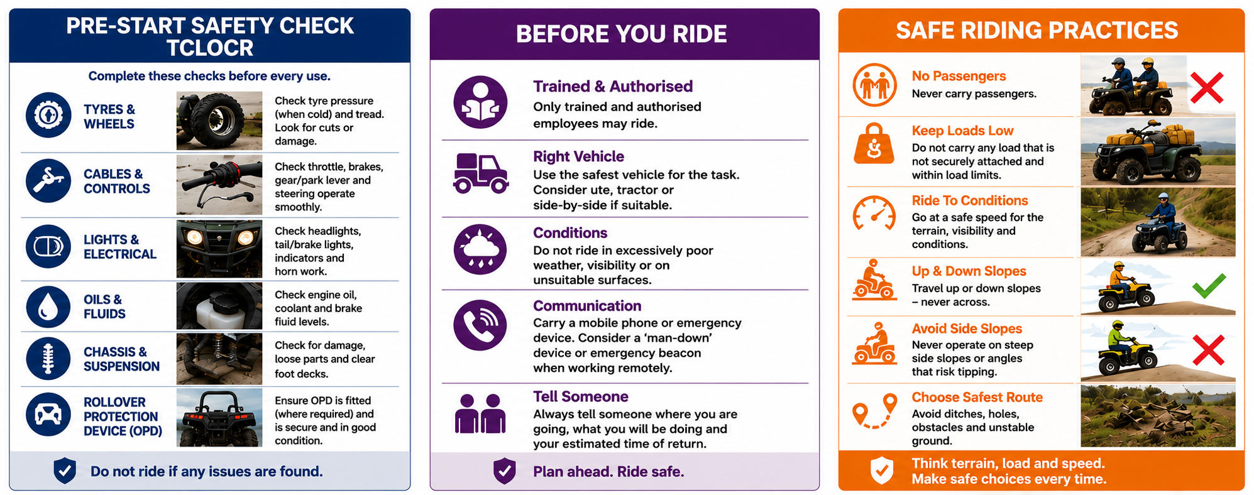
3 | Complete a pre-start inspection  Use the TCLOCR check. Check Tyres and Wheels, Cables and Controls, Lights and Electrical, Oils and Fluids, Chassis and Suspension, and the Rollover or Operator Protective Device before each use. Check tyre pressures when the tyres are cold using a suitable low-pressure gauge. Inspect tyre tread, wheels and tyres for wear, cuts or damage. | Carrying passengers, travelling across steep slopes, overloading carry racks or failing to complete pre-start checks significantly increases the risk of serious injury. Do not operate a quad bike with mechanical faults or damaged safety equipment.
4 | Wear the required PPE  Wear an approved helmet, sturdy boots and suitable work clothing. Wear high-visibility clothing where working remotely, near traffic or on a road. | Helmets must comply with Australian Standards (Australian/New Zealand Standard 1698:2006 – Protective helmets for vehicle users).  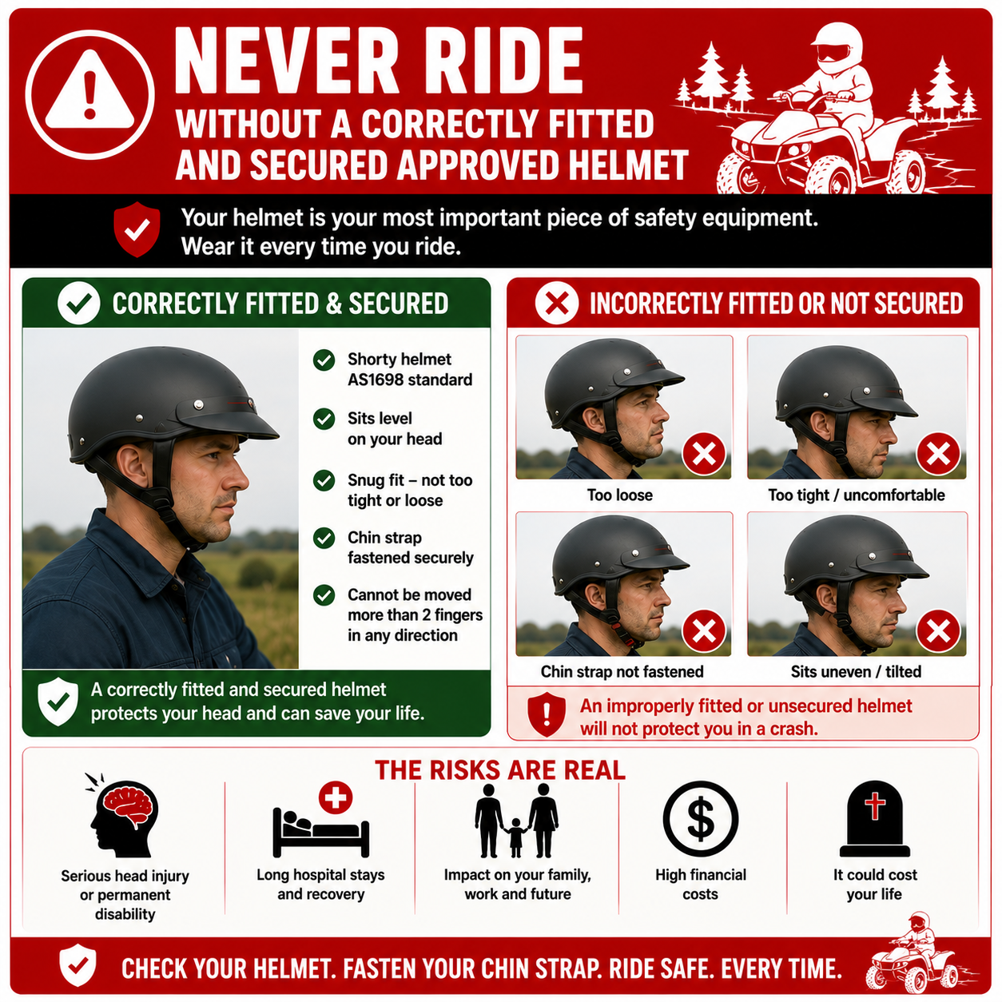
5 | Maintain communication  Carry a mobile phone, emergency alert device or other suitable communication equipment. Tell someone where you are going, what task you are completing and your expected return time. | Agree on what action will be taken if you do not return as expected. Consider a man-down device or emergency beacon where working remotely or outside mobile coverage.
6 | Ride safely  Travel at a safe speed, keep loads within the manufacturer's limits, choose the safest route and travel up or down slopes rather than across them. | Never carry passengers and avoid steep side slopes.
7 | After use  Remove mud and debris, inspect the quad bike for damage, report faults and store PPE appropriately. Store the quad bike, keys, helmet and other PPE in the designated locations so they are clean and ready for the next operator. | Report any defects before the quad bike is used again. Store helmets where they will not be damaged, contaminated or exposed to excessive heat.
NEVER
- Carry passengers.
- Operate a quad bike without an approved helmet.
- Ride across steep side slopes.
- Exceed the manufacturer's load limits.
- Operate a damaged or poorly maintained quad bike.
- Allow untrained or unauthorised people to ride the quad bike.
- Ride on public roads unless all legal requirements have been met.
SPILLS, EXPOSURE AND EMERGENCIES
! | EMERGENCY: If a rollover or other incident occurs, stop work immediately, assess the situation, provide first aid if safe to do so, contact emergency services if required and notify your supervisor. Do not operate a damaged quad bike until it has been inspected and repaired.
DISPOSAL AND ENVIRONMENTAL PROTECTION
Safety and Disposal | Refuel only in well-ventilated areas away from ignition sources and clean up any fuel or oil spills immediately. Wash mud and debris from the quad bike after use and dispose of waste oils, filters and contaminated materials in accordance with the farm's environmental procedures.
FARM-SPECIFIC DETAILS
! | IMPORTANT: Complete these details before this SOP is issued to workers.
Authorised operators
Parking location
Farm speed limit
Fuel storage location
Maintenance records
Emergency contact / farm manager

Disclaimer
Dairy Australia provides this template as general guidance only. Farm businesses are responsible for reviewing, customising and implementing this SOP to suit their own workplace, equipment, hazards and legal obligations. Users should ensure this SOP reflects current legislation, manufacturer instructions, product labels and Safety Data Sheets (SDS) relevant to their business.

