PREPARING BOBBY CALVES FOR SALE
Preparing bobby calves for transport in accordance with animal welfare, traceability and legislative requirements.
SOP NUMBER | VERSION | APPROVED BY | NEXT REVIEW | FARM / BUSINESS NAME
SOP-019 | 1.0
📝 Template Note: This Standard Operating Procedure (SOP) is provided as a template only. It must be reviewed and adapted to reflect your farm business.

PURPOSE AND SCOPE
Purpose  To ensure all bobby calves presented for sale are healthy, fit for transport and meet legislative, animal welfare and traceability requirements. | Scope  This SOP applies to all employees responsible for caring for, assessing, preparing and presenting bobby calves for transport from the farm.
BEFORE YOU START
PPE  Wear clean work clothing, enclosed footwear and disposable gloves when handling calves where appropriate. | EQUIPMENT  Ensure suitable calf handling facilities, NLIS tags, treatment records, National Vendor Declaration (NVD) forms and transport documentation are available before commencing. | PREPARATION  Confirm the collection time, identify calves suitable for transport and ensure all legislative and farm requirements have been met before loading. | TIP  Prepare all documentation before the transport vehicle arrives to minimise loading delays and reduce calf stress.

! | WARNING: Calves that are sick, injured, weak, dehydrated or otherwise unfit for transport must not be consigned for sale. If in doubt, leave the calf behind and seek advice.
PROCEDURE
STEP | WHAT TO DO | SAFETY / QUALITY / ENVIRONMENT
1 | Care for calves from birth  Provide the same standard of care as replacement calves, including adequate colostrum, milk feeding, clean water, shelter and navel treatment. | Handle calves calmly and provide a clean, dry environment.
2 | Do not feed milk from treated or sick cows  Ensure bobby calves are not fed milk from cows under antibiotic treatment or from the sick cow herd. | Observe all meat withholding periods before sale.
3 | Assess fitness for transport  Confirm calves are at least five days old, have been fed milk within the previous six hours and are healthy, alert, strong and free from injury or disease. Check hooves and navels meet transport requirements.  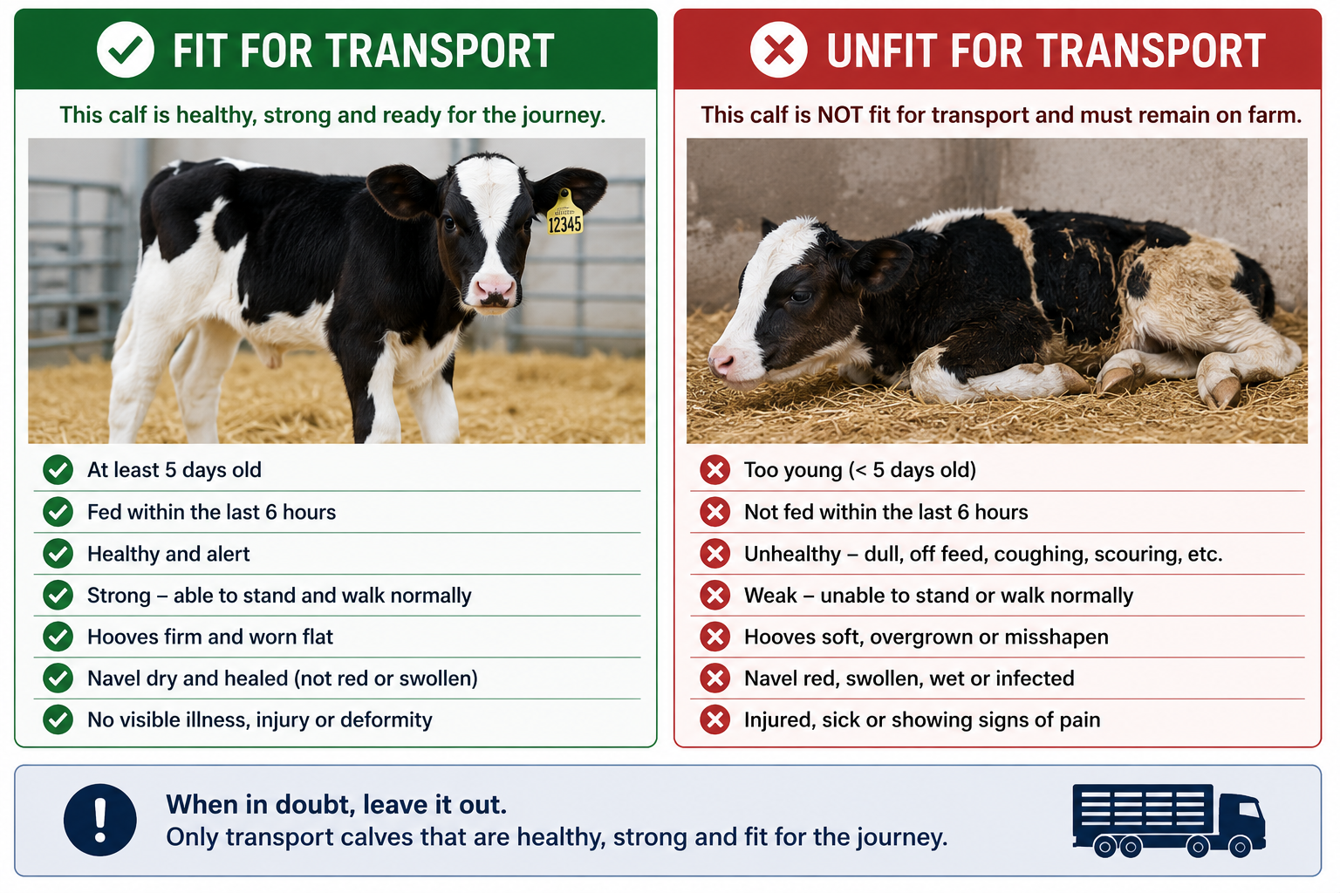 | Only transport calves that are fit for the journey.
4 | Prepare calves for collection  Draft suitable calves into clean holding pens ready for transport. | Handle calves gently. Do not throw, drag, hit or use dogs or electric prodders.
5 | Complete identification and records  Ensure each calf has an NLIS tag fitted in the right ear and record the sale details. | Verify all identification before loading.
6 | Complete transport documentation  Complete the National Vendor Declaration (NVD) before calves leave the property and ensure it is signed by both the farm representative and the transporter. | Documentation must accompany every consignment.
BOBBY CALF TRANSPORT CHECKLIST
REQUIREMENT
At least 5 days old
Fed withing previous 6hrs
Healthy and alert
Able to stand and walk normally
Dry, healed navel
Hooves first and worn flat
No antibiotic holding period
NLIS tag fitted (right ear)
NVD completed and signed
SPILLS, EXPOSURE AND EMERGENCIES
! | EMERGENCY: If a calf becomes injured, distressed or unfit before transport, remove it from the consignment immediately and notify the farm manager. Provide appropriate treatment or veterinary advice where required.
DISPOSAL AND ENVIRONMENTAL PROTECTION
Hygiene and disposal | Maintain clean calf pens and loading areas, minimise stress during handling and dispose of waste in accordance with farm biosecurity and environmental procedures.
FARM-SPECIFIC DETAILS
! | IMPORTANT: Complete these details before this SOP is issued to workers.
Transport company
NVD location
Calf records location
Emergency contact / farm manager

Disclaimer
Dairy Australia provides this template as general guidance only. Farm businesses are responsible for reviewing, customising and implementing this SOP to suit their own workplace, equipment, hazards and legal obligations. Users should ensure this SOP reflects current legislation, manufacturer instructions, product labels and Safety Data Sheets (SDS) relevant to their business.

