WORKING WITH LIVESTOCK
Handling cattle safely to protect people, promote animal welfare and reduce the risk of injury.
SOP NUMBER | VERSION | APPROVED BY | NEXT REVIEW | FARM / BUSINESS NAME
SOP-017 | 1.0
📝 Template Note: This Standard Operating Procedure (SOP) is provided as a template only. It must be reviewed and adapted to reflect your farm business.

PURPOSE AND SCOPE
Purpose  To ensure all employees work safely around dairy cattle by understanding livestock behaviour, using calm handling techniques and following safe work practices. | Scope  This SOP applies to all employees, contractors and visitors who work with or around dairy cows, bulls or calves on the farm.
BEFORE YOU START
PPE  Wear enclosed safety footwear and appropriate work clothing. Gloves should be worn where appropriate for the task. | EQUIPMENT  Ensure the following is available before commencing: Suitable cattle handling facilities (yards, races, crushes or head bail), Communication device (where required), Gates and drafting equipment, Appropriate PPE. | PREPARATION  Assess the cattle before entering the yard or paddock. Observe their behaviour, identify any hazards and ensure all gates, races and handling facilities are safe to use before moving livestock. | TIP  Move quietly, remain aware of your surroundings and allow cattle time to respond to your movements. Calm cattle are safer cattle.

! | WARNING: Never underestimate cattle. Even normally quiet animals can become unpredictable when frightened, isolated or protecting a calf. Bulls require extreme caution and should only be handled using approved farm procedures.
PROCEDURE
STEP | WHAT TO DO | SAFETY / QUALITY / ENVIRONMENT
1 | Assess the livestock  Observe the cattle before approaching. Identify nervous, aggressive, isolated or stressed animals and consider whether cows have young calves. | Understanding animal behaviour helps prevent incidents.
2 | Prepare the work area  Inspect yards, races, gates and handling equipment for hazards before moving cattle. | Safe facilities reduce the risk of injury to people and livestock.
3 | Move cattle calmly  Walk quietly and confidently. Use your position and voice appropriately to encourage movement without shouting or striking animals. | Calm handling improves animal welfare and reduces stress.
4 | Position yourself safely  Stay out of blind spots where possible, respect the animal's flight zone and avoid placing yourself where you could be crushed or kicked.  * To move a single animal forward, stay behind the point of balance and out of the blind spot. When close to the animal, the point of balance is at the shoulder. As you move further away, it may shift forward to just behind the eye. | Always maintain an escape route.  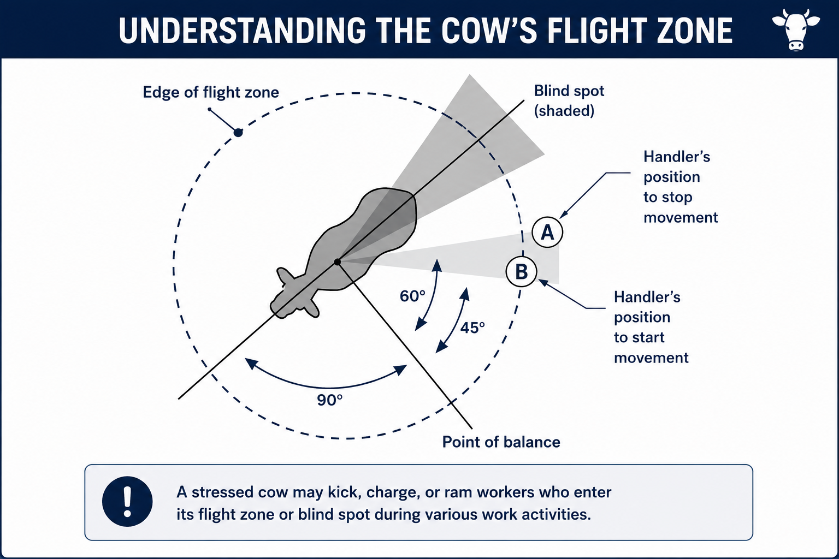
5 | Take extra care around bulls  Never trust a bull, never turn your back on one and always follow the farm's bull handling procedures. Two people should be present when handling bulls where required by farm procedures. | Bulls are more dangerous and unpredictable than dairy cows.
6 | Handle calves safely  Avoid lifting calves where possible and never position yourself between a cow and her newborn calf without suitable protection. Wash your hands after handling calves. | Calves can transmit disease and protective cows can become aggressive.
7 | Work safely in the dairy  Keep hands, arms and head clear of kick rails, gates and moving cattle. Never stand between gates and fences or place hands flat on the dairy platform. | Prevent crush and kick injuries during milking.  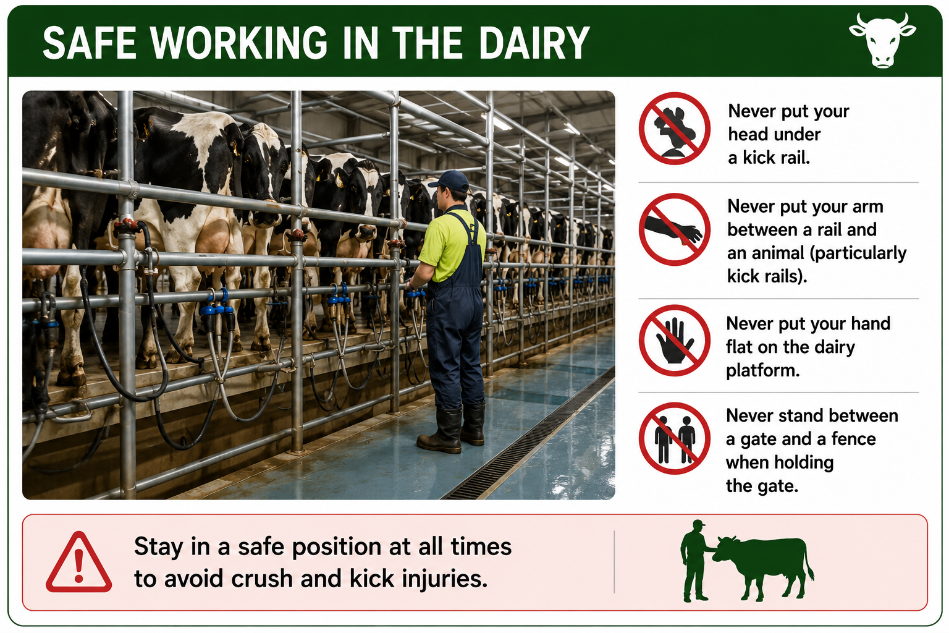
8 | Leave cattle settled  Ensure cattle are calm before leaving the area and report any unsafe behaviour, damaged facilities or incidents to the farm manager. | Good communication helps prevent future incidents.
SPILLS, EXPOSURE AND EMERGENCIES
! | EMERGENCY: If a person is injured by livestock, move to a safe location immediately and seek first aid or emergency assistance as required. If livestock become highly agitated or dangerous, stop work, move to safety and notify the farm owner or manager before attempting to continue.
DISPOSAL AND ENVIRONMENTAL PROTECTION
Hygiene | Wash hands thoroughly after handling calves or livestock, particularly before eating or drinking. Maintain clean handling facilities and remove hazards that may affect animal welfare or worker safety.
Disposal | Dispose of waste in accordance with farm biosecurity and environmental procedures.
FARM-SPECIFIC DETAILS
! | IMPORTANT: Complete these details before this SOP is issued to workers.
Livestock handling facilities
Emergency contact / farm manager

Disclaimer
Dairy Australia provides this template as general guidance only. Farm businesses are responsible for reviewing, customising and implementing this SOP to suit their own workplace, equipment, hazards and legal obligations. Users should ensure this SOP reflects current legislation, manufacturer instructions, product labels and Safety Data Sheets (SDS) relevant to their business.

