USE OF NEEDLES AND INJECTING CATTLE
Safely administering injections to cattle to protect animal welfare, operator safety and food safety.
SOP NUMBER | VERSION | APPROVED BY | NEXT REVIEW | FARM / BUSINESS NAME
SOP-016 | 1.0
📝 Template Note: This Standard Operating Procedure (SOP) is provided as a template only. It must be reviewed and adapted to reflect your farm business.

PURPOSE AND SCOPE
Purpose  To ensure injections are administered safely, accurately and in accordance with veterinary advice, product label directions and food safety requirements. | Scope  This SOP applies to all employees responsible for administering injectable animal health treatments to calves, heifers and adult cattle.
BEFORE YOU START
PPE  Wear disposable gloves, enclosed footwear and appropriate protective clothing. Wear eye protection if there is a risk of splashing or accidental exposure. | EQUIPMENT  Ensure the following equipment is available before commencing:  Approved animal health product  Sterile needles (correct size and gauge)  Syringe or multi-dose injector  Sharps disposal container  Animal restraint facilities  Animal treatment records  Product label or treatment instructions | PREPARATION  Confirm the correct animal, product, dose, route of administration and withholding period before treatment. Ensure cattle are safely restrained and all equipment is clean and in good working order. Any off-label use must be supported by written veterinary advice. | TIP  Change needles regularly to maintain sharpness and minimise infection. Always use a new single-use needle for each animal where applicable.

! | WARNING: Never administer injections unless you understand the product label and the correct injection technique. Accidental self-injection can cause serious injury and requires immediate medical attention.
PROCEDURE
STEP | WHAT TO DO | SAFETY / QUALITY / ENVIRONMENT
1 | Safely restrain the animal  Secure the animal in a crush, head bail or race to minimise movement and allow safe access for injection. Down cows may require a halter or nose grips where appropriate. | Proper restraint protects both the operator and the animal and reduces the risk of needle breakage.  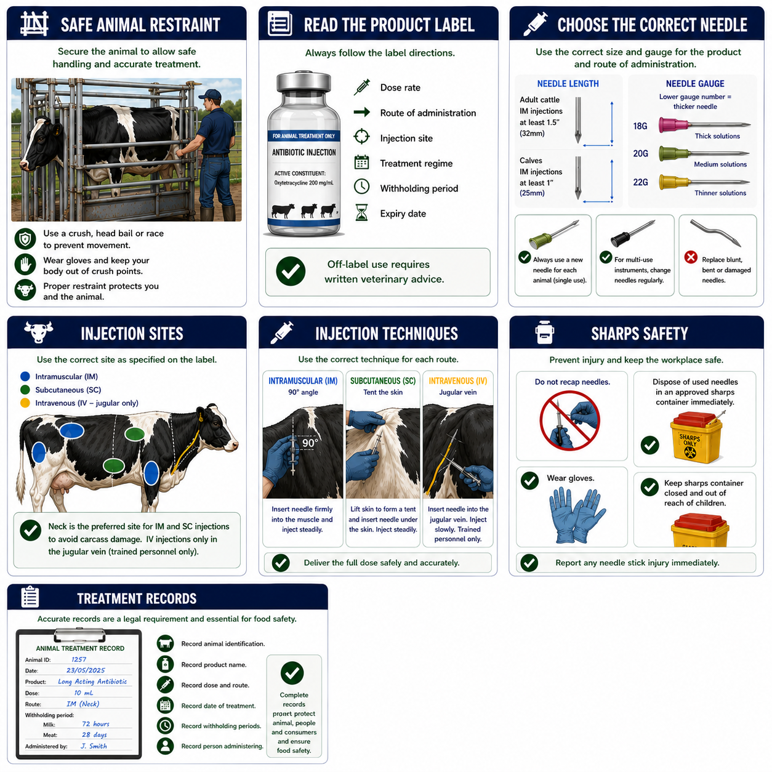
2 | Identify and mark cows  Clearly identify lame, sick or mastitis cows using the farm's approved identification system (e.g. paint, tail tape or leg bands). | Clearly marked cows are easier to identify for treatment and drafting.  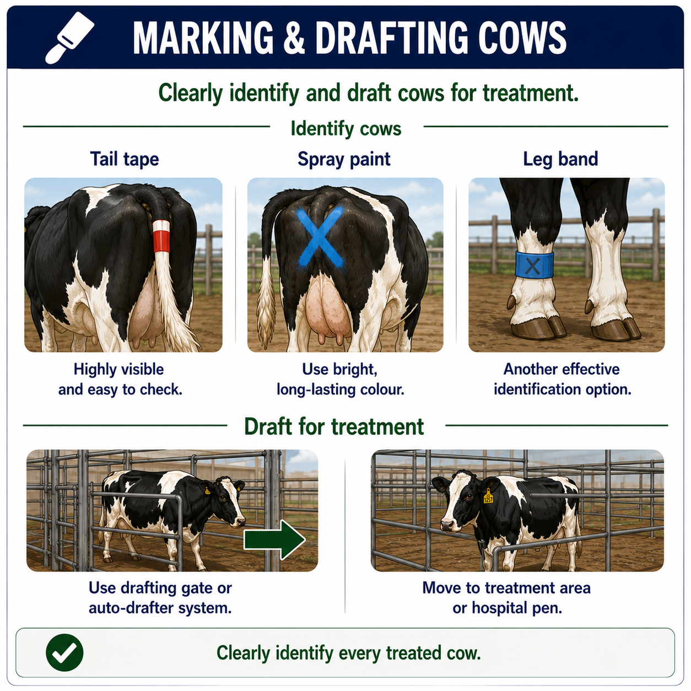
3 | Read the product label  Confirm the product is approved for dairy cattle and check the dose rate, injection route, injection site, treatment regime and withholding periods. | Follow all label directions. Off-label use requires written veterinary advice.
4 | Select the correct needle  Choose the correct needle length and gauge for the product and route of administration. Replace blunt, bent or contaminated needles immediately. | Correct needle selection improves treatment effectiveness and reduces tissue damage.
5 | Select the correct injection site  Administer injections only at the site specified on the product label. Intramuscular and subcutaneous injections should be given in the neck wherever practical to minimise carcass damage. Intravenous injections should only be administered by trained personnel. | Correct injection sites improve animal welfare and meat quality.
6 | Prepare the injection site  Ensure the injection site is clean. If heavily contaminated, clean with an appropriate antiseptic and allow to dry before injecting. | Clean injection sites reduce the risk of infection and abscess formation.
7 | Administer the injection  Inject using the correct technique for the required route (intramuscular, subcutaneous or intravenous). Deliver the full dose steadily and safely. | Maintain control of the animal and keep hands away from the needle at all times.
8 | Dispose of needles safely  Place used needles directly into an approved sharps container. Never reuse damaged needles or leave sharps in the work area. | Prevents injury and contamination.
9 | Record the treatment  Record the animal ID, product, dose, route of administration, withholding period, date and person administering treatment. | Accurate treatment records are essential for food safety and quality assurance.
SPILLS, EXPOSURE AND EMERGENCIES
! | EMERGENCY: If accidental self-injection occurs, seek immediate medical attention and take the product label or Safety Data Sheet (SDS) with you. Report all incidents to the farm owner or manager. If an animal has an adverse reaction following treatment, seek veterinary advice immediately.
DISPOSAL AND ENVIRONMENTAL PROTECTION
Hygiene | Maintain clean injection equipment and replace needles regularly.
Disposal | Dispose of used needles in an approved sharps container and dispose of empty product containers according to label instructions and farm waste procedures. Prevent medicines and contaminated waste from entering waterways, drains or paddocks.
FARM-SPECIFIC DETAILS
! | IMPORTANT: Complete these details before this SOP is issued to workers.
Approved treatment products
Sharps container location
Treatment record location
Veterinarian contact
Emergency contact / farm manager

Disclaimer
Dairy Australia provides this template as general guidance only. Farm businesses are responsible for reviewing, customising and implementing this SOP to suit their own workplace, equipment, hazards and legal obligations. Users should ensure this SOP reflects current legislation, manufacturer instructions, product labels and Safety Data Sheets (SDS) relevant to their business.

