IDENTIFICATION, REPORTING AND TREATMENT OF SICK COWS
Promptly identifying, reporting and managing sick or injured cows to support animal welfare, milk quality and food safety.
SOP NUMBER | VERSION | APPROVED BY | NEXT REVIEW | FARM / BUSINESS NAME
SOP-015 | 1.0
📝 Template Note: This Standard Operating Procedure (SOP) is provided as a template only. It must be reviewed and adapted to reflect your farm business.

PURPOSE AND SCOPE
Purpose  To ensure sick, lame or injured cows are identified promptly, reported, treated appropriately and accurately recorded to maintain high standards of animal welfare and milk quality. | Scope  This SOP applies to all employees responsible for identifying, reporting, drafting and treating sick, lame or injured cows during milking operations.
BEFORE YOU START
PPE  Wear appropriate PPE including gloves, enclosed footwear and protective clothing when handling or treating sick animals. | EQUIPMENT  Ensure the following equipment is available before commencing:  Animal treatment record  Identification equipment (tail tape, paint, leg bands etc.)  Drafting system or drafting equipment  Treatment equipment (where required)  Approved medications (if required) | PREPARATION  Before milking begins, ensure all staff understand the farm's identification and reporting procedures and know how to record sick or treated animals. | TIP  Communicate any sick or lame cows identified during cow collection to the herdsperson before milking begins. Failing to report or clearly identify sick cows can delay treatment and increase the risk of contaminated milk entering the vat.

! | WARNING: Milk from sick cows, cows with clinical mastitis or cows under treatment must not enter the milk vat.
PROCEDURE
STEP | WHAT TO DO | SAFETY / QUALITY / ENVIRONMENT
1 | Identify sick cows  While collecting cows for milking, observe all animals for signs of illness, lameness, mastitis or injury. Record any cows requiring attention. | Early identification supports prompt treatment and good animal welfare.  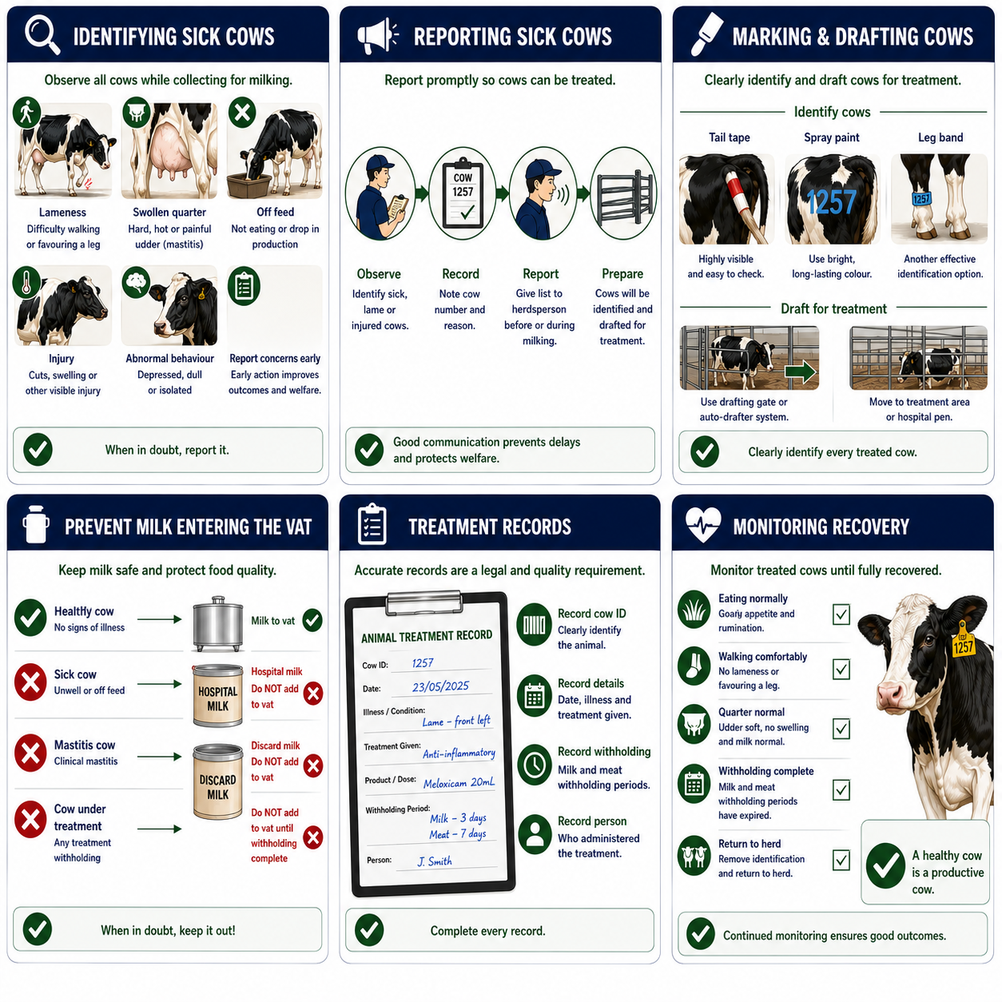
2 | Report affected cows  Provide the list of sick or lame cows to the herdsperson before or during milking so the animals can be identified and managed. | Good communication helps ensure no animals are overlooked.
3 | Identify and mark cows  Clearly identify lame, sick or mastitis cows using the farm's approved identification system (e.g. paint, tail tape or leg bands). | Clearly marked cows are easier to identify for treatment and drafting.  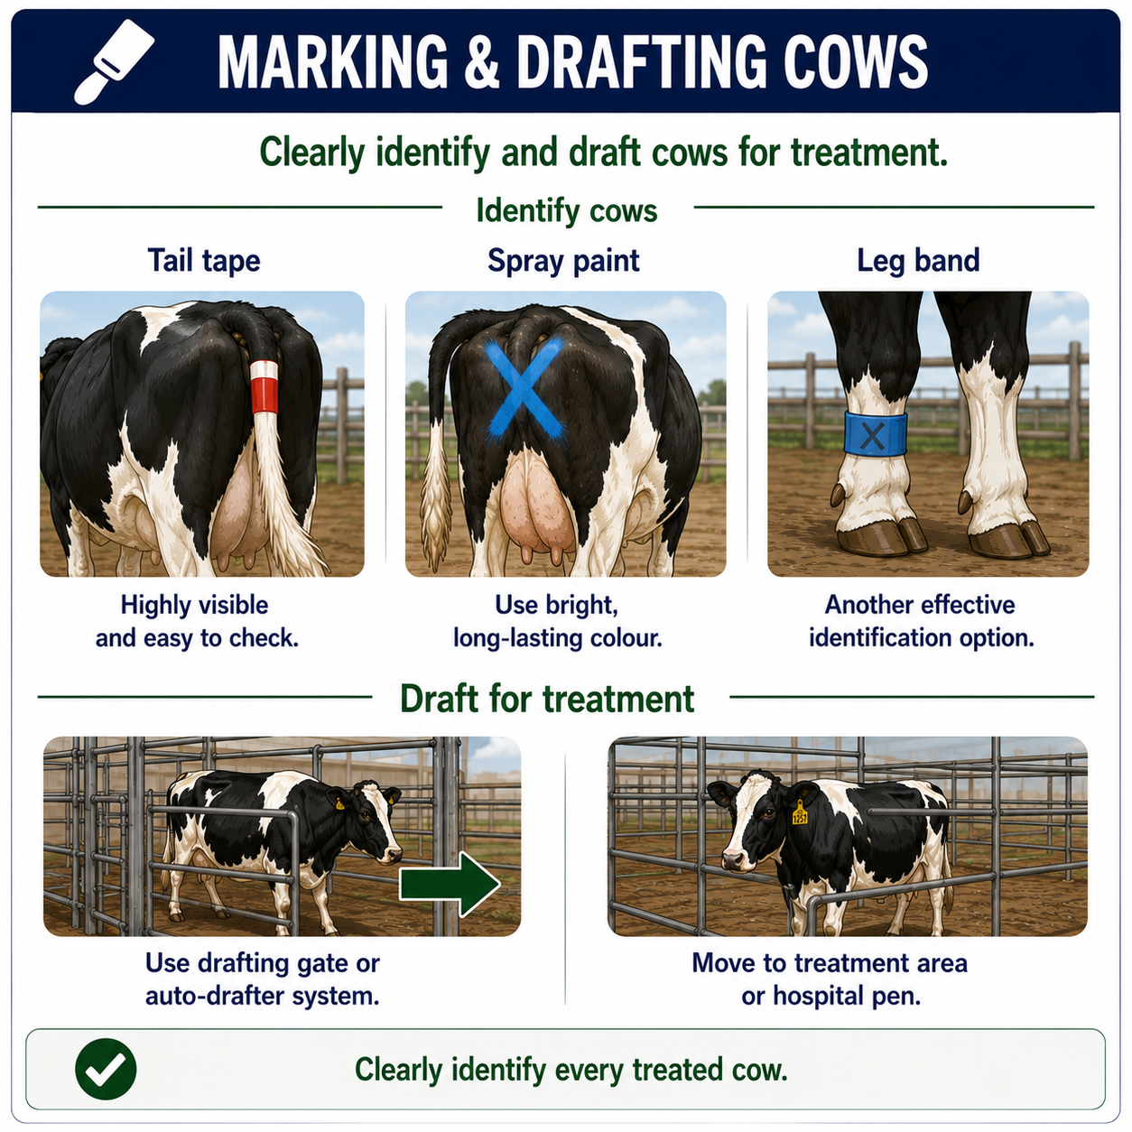
4 | Draft cows for treatment  Draft affected cows into the designated treatment area or hospital group using the drafting system or manual drafting procedures. | Minimise stress by handling cattle quietly and calmly.
5 | Treat affected cows  Administer treatment as directed by the farm manager, veterinarian or herd health program, following all product instructions and withholding periods. | Follow the relevant treatment procedures where applicable.
6 | Prevent contaminated milk entering the vat  Ensure milk from sick cows, cows with clinical mastitis and cows under treatment is diverted or discarded in accordance with farm procedures. | Protects milk quality and food safety.
7 | Complete treatment records  Record all treatments, including the cow identification, condition, treatment given, date, withholding periods and person administering the treatment. | Permanent treatment records are an auditable requirement under quality assurance programs.
8 | Monitor recovery  Continue monitoring treated cows and remove identification only when treatment has been completed, withholding periods have expired and the animal has recovered. | Ongoing monitoring supports animal welfare and treatment success.

SPILLS, EXPOSURE AND EMERGENCIES
! | EMERGENCY: If a cow is seriously ill, injured or unable to stand, notify the farm owner or manager immediately and seek veterinary assistance where required. Ensure the animal is isolated if appropriate and handled safely to minimise stress and further injury.
DISPOSAL AND ENVIRONMENTAL PROTECTION
Hygiene | Maintain good hygiene by cleaning and disinfecting treatment equipment between animals where appropriate.
Disposal | Dispose of used treatment materials in accordance with farm biosecurity and waste management procedures. Prevent contaminated milk, medications and waste from entering waterways, drains or the environment.
FARM-SPECIFIC DETAILS
! | IMPORTANT: Complete these details before this SOP is issued to workers.
Approved identification method
Hospital herd location
Treatment record location
Veterinarian contact
Milk withholding procedure/period
Emergency contact / farm manager

Disclaimer
Dairy Australia provides this template as general guidance only. Farm businesses are responsible for reviewing, customising and implementing this SOP to suit their own workplace, equipment, hazards and legal obligations. Users should ensure this SOP reflects current legislation, manufacturer instructions, product labels and Safety Data Sheets (SDS) relevant to their business.

