NEWBORN CALF CARE
Providing newborn calves with a clean, healthy start through safe housing, identification and navel care.
SOP NUMBER | VERSION | APPROVED BY | NEXT REVIEW | FARM / BUSINESS NAME
SOP-014 | 1.0
📝 Template Note: This Standard Operating Procedure (SOP) is provided as a template only. It must be reviewed and adapted to reflect your farm business.

PURPOSE AND SCOPE
Purpose  To ensure all newborn calves receive appropriate care immediately after arrival in the calf shed by providing clean housing, correct identification and effective navel disinfection to support health, welfare and disease prevention. | Scope  This SOP applies to all employees responsible for receiving, identifying and caring for newborn calves entering the calf rearing facility.
BEFORE YOU START
PPE  Wear clean boots, gloves and suitable protective clothing. Wash or sanitise hands before handling calves and between sick and healthy animals. | EQUIPMENT  Ensure the following equipment is available before calves arrive:  Management tags  NLIS tags (bull calves where applicable)  Tag applicator  5% iodine solution  Clean spray bottle or dip container  Animal treatment records  Clean calf pens with fresh bedding | PREPARATION  Ensure calf pens are clean, dry and bedded before calves arrive. Check that adequate ventilation, shelter and clean drinking water are available. Prepare identification equipment and fresh iodine solution before unloading calves. | TIP  Organise calves into appropriate groups before unloading to minimise handling and reduce stress.

! | WARNING: Only place calves into clean, dry pens. Dirty bedding and poor ventilation increase the risk of disease.
PROCEDURE
STEP | WHAT TO DO | SAFETY / QUALITY / ENVIRONMENT
1 | Prepare calf housing  Ensure calf pens are clean, dry, well bedded and protected from wind and rain before calves arrive. | Clean, dry housing reduces disease risk and improves calf comfort.  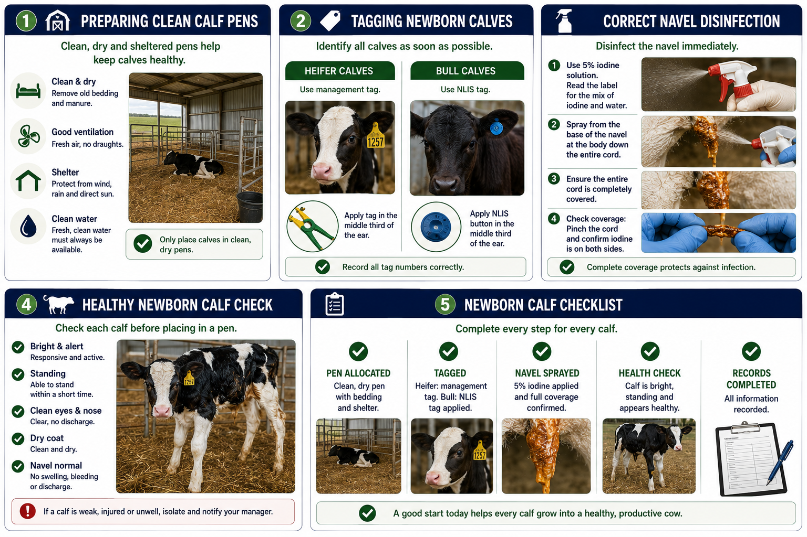
2 | Allocate calves to pens  Place heifer calves into designated heifer pens and sale calves into designated sale pens according to the farm's stocking rates. | Avoid overcrowding and ensure adequate ventilation.
3 | Check calf health  Observe each calf for signs of injury, weakness or illness before placing it into a pen. Report concerns immediately. | Early identification allows prompt treatment
4 | Identify calves  Tag heifer calves with management tags and bull calves with NLIS tags in accordance with the farm's tagging procedures. (See Tagging and removing calves SOP). | Confirm tag numbers are recorded correctly.
5 | Disinfect the navel  Immediately spray or dip the entire umbilical cord using fresh 5% iodine solution. Start at the base of the navel and work down until the cord is completely covered. | The entire cord should be saturated with iodine. Failing to completely cover the umbilical cord with iodine reduces its effectiveness and increases the risk of infection.
6 | Check iodine coverage  Confirm disinfectant has completely covered the cord. A simple check is to pinch the cord gently and ensure iodine is present on both sides. | Incomplete coverage reduces protection against infection.
7 | Maintain iodine solution  Replace iodine solution regularly (approximately every two days or sooner if contaminated). Use only fresh 5% iodine solution. | Do not use teat spray as a substitute because it contains emollients.
8 | Complete records  Record calf identification and any observations or treatments according to farm procedures. | Accurate records support calf management and traceability. Confirm every calf has been correctly identified, housed appropriately and had its navel disinfected before leaving the receiving area.
SPILLS, EXPOSURE AND EMERGENCIES
! | EMERGENCY: If a calf is weak, injured or showing signs of illness, isolate the calf where appropriate, notify the farm owner or manager immediately and seek veterinary advice if required.
DISPOSAL AND ENVIRONMENTAL PROTECTION
Hygiene | Maintain high standards of hygiene by cleaning and disinfecting calf pens, equipment and hands before handling newborn calves.
Disposal | Dispose of used gloves, wipes and waste appropriately and replace contaminated bedding promptly. Prevent waste and contaminated materials from entering waterways or drains.
FARM-SPECIFIC DETAILS
! | IMPORTANT: Complete these details before this SOP is issued to workers.
Maximum calves per heifer pen
Maximum calves per sale pen
Iodine concentration
Location of calf records
Emergency contact / farm manager

Disclaimer
Dairy Australia provides this template as general guidance only. Farm businesses are responsible for reviewing, customising and implementing this SOP to suit their own workplace, equipment, hazards and legal obligations. Users should ensure this SOP reflects current legislation, manufacturer instructions, product labels and Safety Data Sheets (SDS) relevant to their business.

