DRY COW THERAPY AND TEAT SEALING
Safely administering dry cow treatment and internal teat sealant to reduce mastitis and protect udder health during the dry period.
SOP NUMBER | VERSION | APPROVED BY | NEXT REVIEW | FARM / BUSINESS NAME
SOP-013 | 1.0
📝 Template Note: This Standard Operating Procedure (SOP) is provided as a template only. It must be reviewed and adapted to reflect your farm business.

PURPOSE AND SCOPE
Purpose  To ensure dry cow therapy and internal teat sealants are administered safely, hygienically and consistently to reduce mastitis, protect udder health and maintain milk quality. | Scope  This SOP applies to trained employees responsible for administering dry cow antibiotic therapy and internal teat sealant to cows at dry-off, and internal teat sealant to maiden heifers before first calving.
BEFORE YOU START
PPE  Wear clean disposable gloves, protective clothing, enclosed footwear and safety glasses where required. Change or disinfect gloves between cows. | EQUIPMENT  Ensure all equipment and products are available, clean and within expiry dates, including:  Dry cow treatment syringes  Internal teat sealant syringes  70% alcohol wipes or cotton balls soaked in 70% alcohol  70% alcohol spray  Teat disinfectant  Identification materials (paint, tail tape etc.)  Animal treatment records  Waste container | PREPARATION  Draft cows into a separate group at least one milking before dry-off and confirm they meet the farm's dry-off criteria. Ensure sufficient trained staff are available, prepare a clean dairy platform and gather all equipment before commencing treatment. | TIP  Treat cows in small batches, maintain excellent hygiene and work methodically from the front teats to the back teats to reduce contamination.

! | WARNING: Always administer dry cow treatment before internal teat sealant. Never use a syringe that has touched dirt, manure, water or the cow's leg. Discard contaminated syringes immediately.
PROCEDURE
STEP | WHAT TO DO | SAFETY / QUALITY / ENVIRONMENT
1 | Select and draft cows  Confirm cows are scheduled for dry-off (generally 6–8 weeks before calving producing 5-12L), meet the farm's milk production criteria and draft them into a separate group at least one milking before treatment. | Record cows producing below the farm's minimum milk production target, as they may require residue testing after calving. (Cows producing less than 5L have a higher risk of antibiotic residues at calving time).
2 | Organise treatment batches  Ensure sufficient trained staff are available and limit each treatment batch to a manageable number (approximately 20 cows per trained person). | Smaller batches improve hygiene and reduce treatment errors.
3 | Prepare the dairy  Milk the main herd first, thoroughly wash the dairy platform and yards, then bring the dry-off group into the clean dairy. Milk each cow out completely. | A clean environment reduces the risk of introducing bacteria into the teat canal.
4 | Prepare equipment and products  Gather all treatment products, disinfectants, identification materials and records. Check expiry dates and withholding periods. Keep syringes clean and dry. On cold days, warm products using an indirect method without allowing syringes to contact water. | Never place syringes directly into water. Discard any syringe that becomes contaminated.  Ensure that the planned dry period of the cow exceeds the WHP of the dry cow treatment.
5 | Identify and record cows  Clearly identify each treated cow using two forms of identification (e.g. paint and tail tape) and record the cow ID, products used, treatment date and withholding periods. | Accurate identification prevents treated milk entering the vat.
6 | Restrain the cow safely  Restrain the cow where required. Use a trained assistant to tail jack if necessary before commencing treatment. | Remain alert for kicking, stepping or sudden movement.
7 | Clean and disinfect teat ends  Disinfect gloves with 70% alcohol between cows. Thoroughly clean each teat end using a fresh alcohol wipe or cotton ball. Vigorously scrub the teat end until all dirt and manure have been removed-more than one wipe or cotton ball may be needed to clean each teat. Use a new wipe for every teat. | Excellent teat-end hygiene is essential to prevent introducing bacteria into the udder.  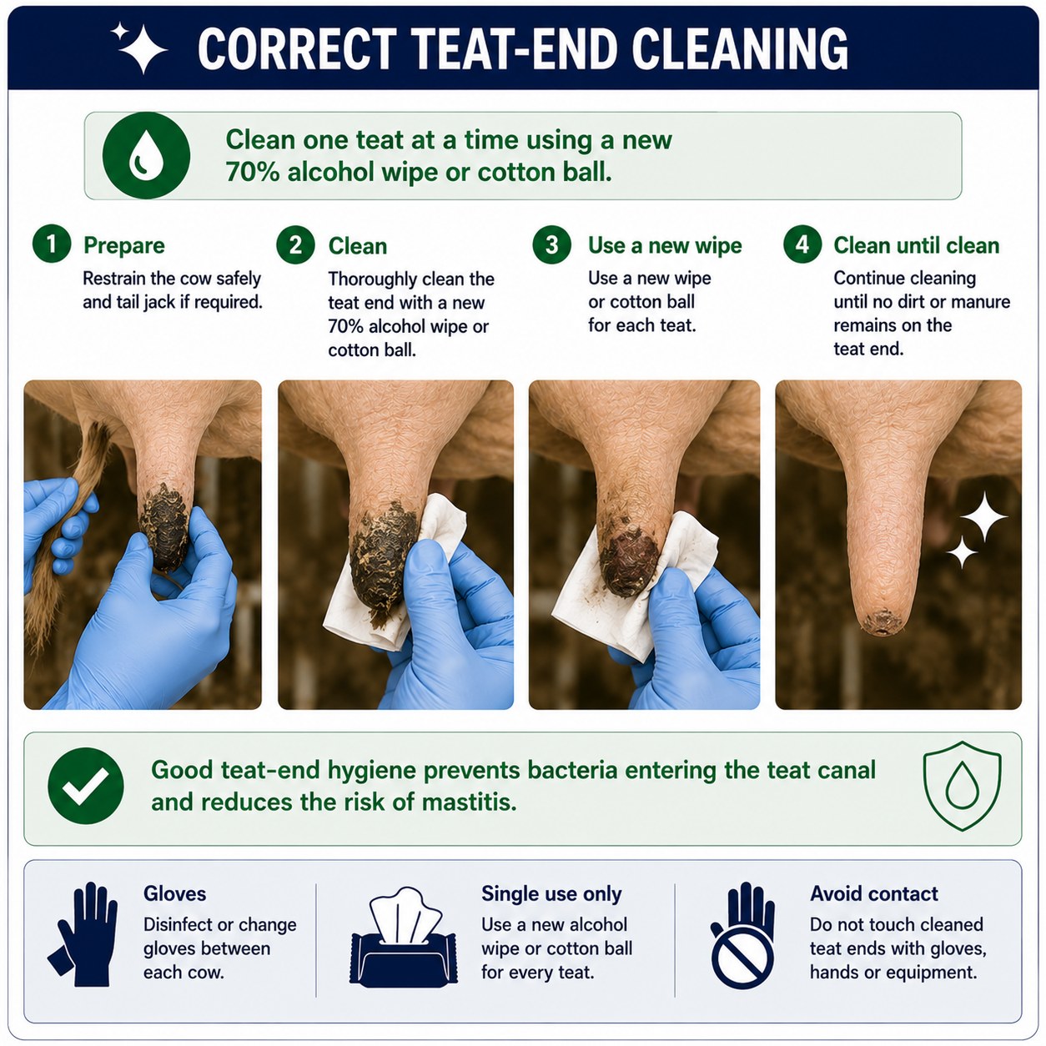
8 | Administer dry cow treatment  Working from the front teats to the back teats: Disinfect teat end, remove the syringe cap carefully without contaminating the tip. Insert only the tip of the syringe into the teat canal, administer the full contents and gently massage the treatment into the teat and quarter. | Dry cow treatment must always be administered before teat sealant.  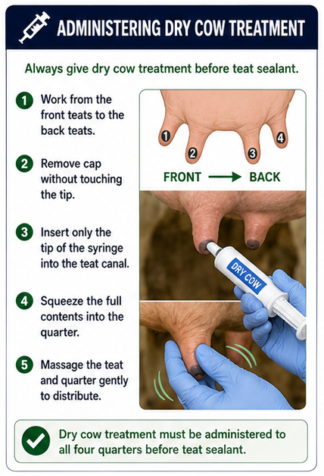
9 | Administer internal teat sealant  Using a clean syringe, insert only the tip into the teat canal. Pinch the top of the teat while administering the sealant until the teat feels full. Release gently. Do not massage the sealant into the udder. | The sealant must remain within the teat canal to provide an effective barrier against infection.  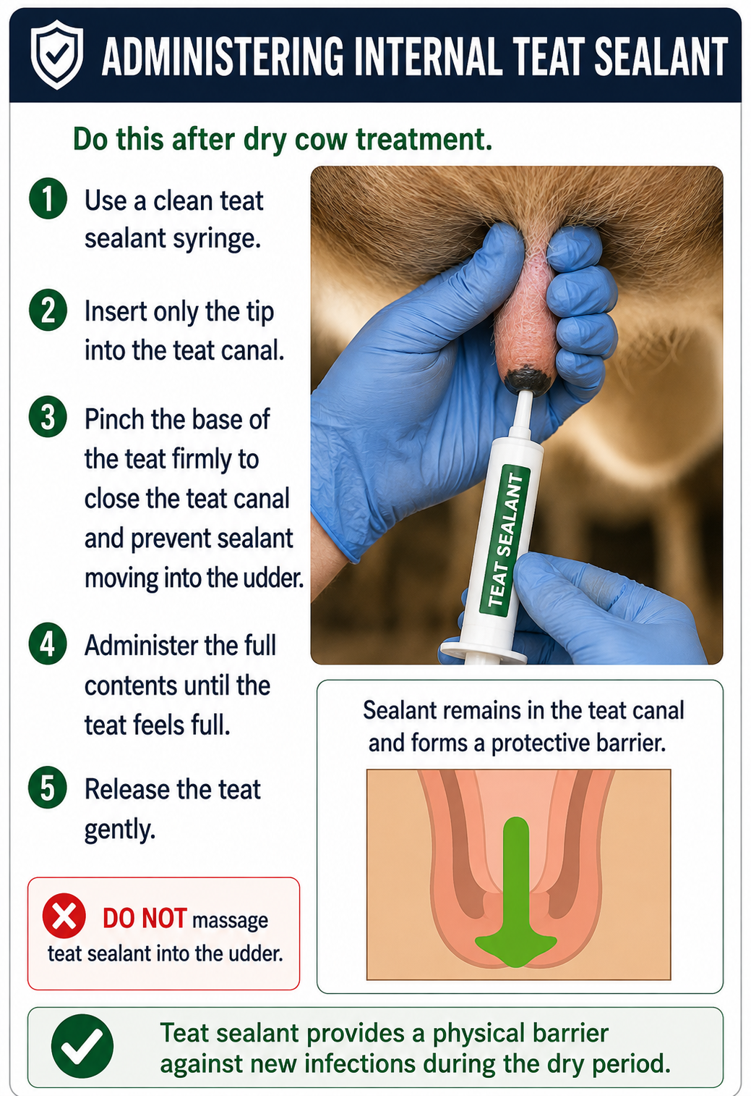
10 | Strip sealant  Teat sealant must be removed from fresh cows. Prior to putting cups on at the first milking, strip each treated quarter at least 10-12 times or until all the teat sealant has been removed. Repeat this at each milking for the first 4 days of lactation | Strip the entire quarter by starting at the top of the teat where it meets the udder and working all the way down.
11 | Apply teat disinfectant  Thoroughly spray or dip all teat surfaces with teat disinfectant immediately after treatment. | Ensure complete coverage of all teats.
12 | Move cows to a clean paddock  Walk treated cows calmly to a clean, dry paddock away from the dairy. Avoid allowing cows to lie down in dirty areas for approximately two hours after treatment. | Clean surroundings reduce the risk of new infections entering the teat canal.
13 | Complete records  Finalise all QA treatment records, confirm withholding periods, and ensure all treated animals have been correctly identified. Arrange residue testing where required before milk returns to the vat. | Accurate records support food safety and traceability.
14 | Prepare maiden heifers  Move small groups of heifers quietly onto the platform. Where practical, train heifers to enter the dairy before treatment. Heifers are not milked before teat sealing. Tail jacking or approved sedation may be used where appropriate. | Calm handling reduces stress and the risk of injury to people and animals.
15 | Administer teat sealant to heifers  Clean teat ends thoroughly and administer internal teat sealant using the same hygienic partial-insertion technique used for cows. Apply teat disinfectant afterwards and allow heifers to leave the platform calmly. | Heifers generally receive teat sealant only and should be handled quietly throughout the procedure.
SPILLS, EXPOSURE AND EMERGENCIES
! | EMERGENCY: If a worker is injured or an animal becomes distressed during treatment, stop work immediately, make the area safe, notify the farm owner or manager and seek veterinary or medical assistance if required.
DISPOSAL AND ENVIRONMENTAL PROTECTION
Hygiene | Maintain high standards of hygiene throughout the procedure by using clean equipment, disinfecting gloves between cows and preventing contamination of treatment products. Keep the treatment area clean and tidy.
Disposal | Dispose of used syringes, alcohol wipes, gloves and packaging in accordance with farm biosecurity and waste management procedures. Prevent contaminated waste from entering waterways or paddocks and keep treatment areas clean and tidy.
FARM-SPECIFIC DETAILS
! | IMPORTANT: Complete these details before this SOP is issued to workers.
Dry off milk production target
Dry cow treatment product
Internal teat sealant product
Milk withholding period
Animal treatment record location
Emergency contact / farm manager

Disclaimer
Dairy Australia provides this template as general guidance only. Farm businesses are responsible for reviewing, customising and implementing this SOP to suit their own workplace, equipment, hazards and legal obligations. Users should ensure this SOP reflects current legislation, manufacturer instructions, product labels and Safety Data Sheets (SDS) relevant to their business.

