FENCING – USING A CHAIN STRAINER
Safely using a chain strainer to tension fencing wire and complete strong, secure repairs.
SOP NUMBER | VERSION | APPROVED BY | NEXT REVIEW | FARM / BUSINESS NAME
SOP-012 | 1.0
📝 Template Note: This Standard Operating Procedure (SOP) is provided as a template only. It must be reviewed and adapted to reflect your farm business.

PURPOSE AND SCOPE
Purpose  To ensure chain strainers are used safely and correctly when tensioning fencing wire. | Scope  This SOP applies to authorised workers using a chain strainer to repair, join or tension plain or barbed fencing wire.
BEFORE YOU START
PPE  Wear safety glasses, gloves, sturdy protective footwear, long sleeves and suitable sun protection. | EQUIPMENT  Ensure both parts of the chain strainer are present and in good working condition: the chain and clamp, and the handle and clamp. Have suitable fencing tools and approved wire-joining materials available. | PREPARATION  Inspect the fence, wire and work area before starting. Isolate electric fencing where applicable, keep livestock and other people clear, and plan where to stand so you are not in the line of fire if the wire breaks.

! | WARNING: Fencing wire stores significant energy when tensioned and may recoil without warning. Keep clear of the wire’s path and never release the chain suddenly.
PROCEDURE
STEP | WHAT TO DO | SAFETY / QUALITY / ENVIRONMENT
1 | Inspect  Check that the chain, handle, hooks and clamps are complete, undamaged and operating correctly. | Do not use damaged or poorly maintained equipment.  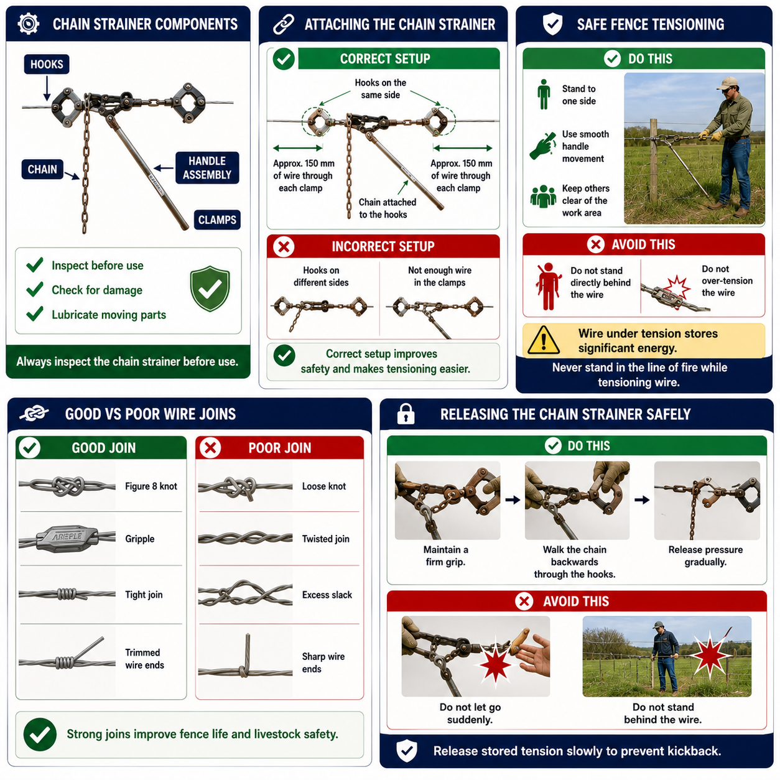
2 | Attach the first clamp  Position both hooks on the same side of the handle. Place the wire into the clamp with approximately 150 mm extending through it. | Keep fingers clear of the clamp and moving parts.
3 | Tighten the first clamp  Squeeze the clamp closed and pull the wire firmly so the clamp grips securely. Maintain light tension to hold it in position. | Confirm the wire cannot slip from the clamp.
4 | Attach the chain  Hook the loose end of the chain into the hooks on the handle section. | Avoid placing fingers between the chain and hooks.
5 | Attach the second clamp  Extend the chain and second clamp towards the loose wire. Attach the wire using the same method and keep the chain and wire under light tension. | Assume the wire may break at any time and remain out of the line of fire.
6 | Tension the fence  Operate the handle so the hooks move along the chain and gradually pull the two wire ends together. Guide the chain carefully where required. | Stand to one side, keep others clear and do not over-tension.
7 | Complete the wire join  Join the wires using an approved method, such as a Figure 8 knot or Gripple. Trim or secure protruding wire ends. | Ensure the join is strong, tidy and free from sharp ends.
8 | Release the tension  Walk the chain backwards through the hooks while maintaining a firm grip. Release the pressure gradually, remove the chain and open the clamps. | Never let the chain go suddenly. Remain clear of possible kickback.
9 | Inspect the repair  Confirm the wire is secure, correctly tensioned and aligned, then remove tools and waste wire from the area. | Confirm the wire is secure, correctly tensioned and aligned, then remove tools and waste wire from the area.
SKILLS, EXPOSURE AND EMERGENCIES
! | EMERGENCY: If the wire breaks, recoils or causes an injury, stop work immediately, make the area safe and notify the farm owner or manager. Provide first aid if trained and call 000 if required.
DISPOSAL AND ENVIRONMENTAL PROTECTION
Remove waste | Remove all wire offcuts, damaged components and packaging from the paddock. Dispose of waste safely to prevent injury to livestock, people, wildlife and machinery.
FARM-SPECIFIC DETAILS
! | IMPORTANT: Complete these details before this SOP is issued to workers.
Chain strainer storage location
Approved wire joining method
Fence wire type
Electric fence isolation point
Emergency contact / farm manager

Disclaimer
Dairy Australia provides this template as general guidance only. Farm businesses are responsible for reviewing, customising and implementing this SOP to suit their own workplace, equipment, hazards and legal obligations. Users should ensure this SOP reflects current legislation, manufacturer instructions, product labels and Safety Data Sheets (SDS) relevant to their business.

