REPAIRING A BROKEN FENCE
Safely repairing damaged fences to maintain livestock containment and fence performance.
SOP NUMBER | VERSION | APPROVED BY | NEXT REVIEW | FARM / BUSINESS NAME
SOP-011 | 1.0
📝 Template Note: This Standard Operating Procedure (SOP) is provided as a template only. It must be reviewed and adapted to reflect your farm business.

PURPOSE AND SCOPE
Purpose  To ensure broken fences are repaired safely, effectively and to a standard that maintains livestock containment and farm safety. | Scope  This SOP applies to all authorised workers responsible for inspecting and repairing conventional and electric fences.
BEFORE YOU START
PPE  Wear enclosed footwear, gloves, long sleeves and safety glasses when handling fencing wire. Additional PPE may be required when using power tools. | EQUIPMENT  Ensure all required fencing tools, replacement wire, strainers, insulators, connectors (Figure 8 knots or Gripples), fence tester (for electric fences) and PPE are available and in good condition. | PREPARATION  Inspect the damaged fence, identify the cause of the damage and ensure the work area is safe. If repairing an electric fence, isolate and switch off the power before commencing repairs.

! | WARNING: Always isolate electric fences before commencing repairs. Fencing wire is under tension and can recoil unexpectedly, causing serious injury.
PROCEDURE
STEP | WHAT TO DO | SAFETY / QUALITY / ENVIRONMENT
1 | Inspect  Assess the damaged fence, identify broken wires, damaged posts, insulators or other components requiring replacement. | Determine whether the fence can be repaired safely.
2 | Isolate the fence  Switch off the energiser and confirm there is no power using a fence tester before touching any electric fence wires. | Never work on a live electric fence.
3 | Assess existing wire  Reuse existing wire only if it is straight, undamaged and free from severe kinks or tight bends. | Damaged wire is more likely to fail after repair. Attempting to reuse badly kinked, twisted or damaged wire often results in weak repairs and future fence failures.
4 | Replace wire  Install new wire where necessary and connect it using a Figure 8 knot or Gripple. | Remove sharp wire ends and ensure all joins are secure.  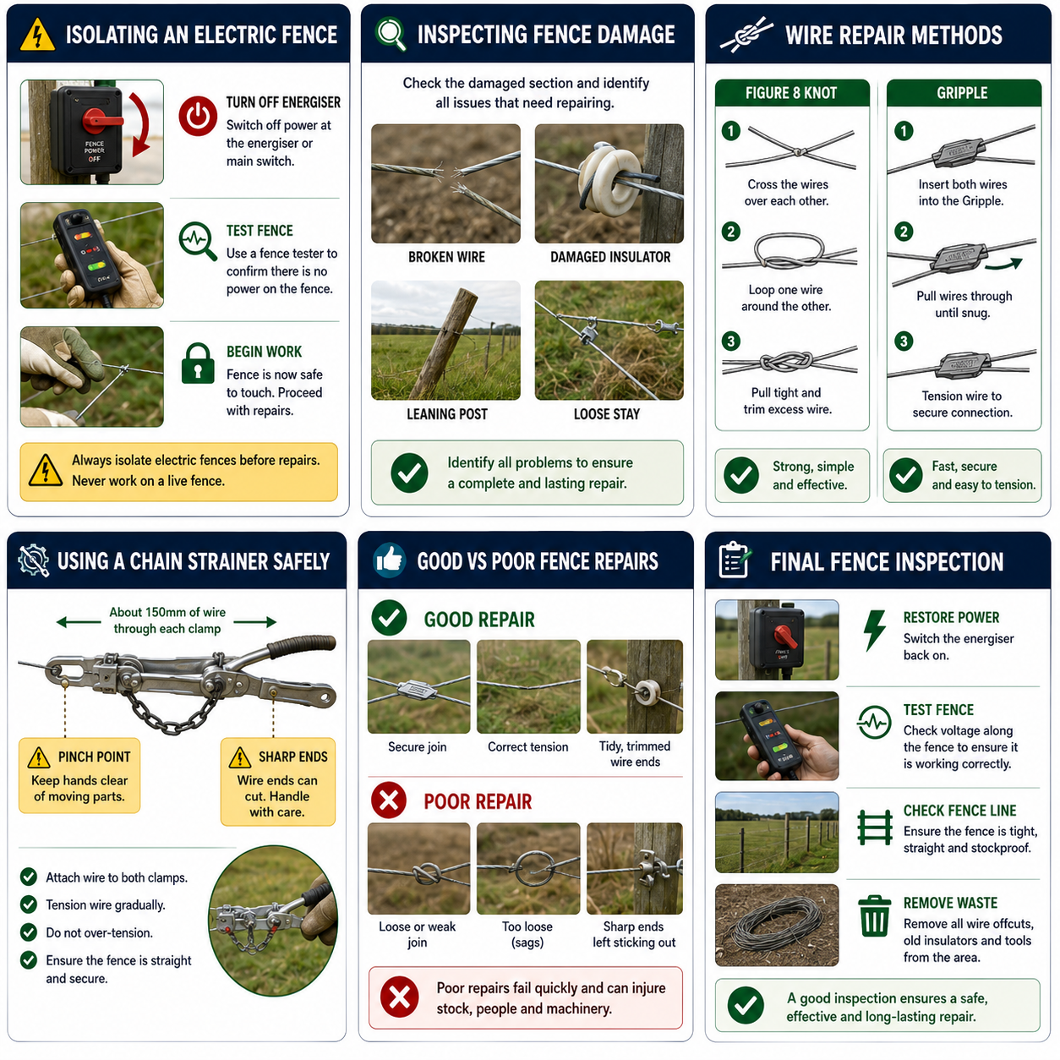
5 | Tension  Use a chain strainer to tension the fence until the correct wire tension is achieved. | Keep hands clear of pinch points and avoid over-tensioning.
6 | Complete  Secure all joins, replace damaged insulators and ensure the fence line is straight and correctly supported. | A tidy repair improves fence strength and longevity.
7 | Restore power  Reconnect the energiser (if applicable) and test the fence to confirm it is operating correctly. | Ensure livestock cannot access the fence during testing.
8 | Final inspection  Walk the repaired section, remove waste wire and tools, and confirm the fence is safe and stockproof. | Report any major damage requiring further repair.
SKILLS, EXPOSURE AND EMERGENCIES
! | EMERGENCY: If a worker is injured or fencing wire recoils unexpectedly, stop work immediately, provide first aid if trained and notify the farm owner or manager. Contact emergency services (000) if required.
DISPOSAL AND ENVIRONMENTAL PROTECTION
Remove waste | Dispose of damaged wire, insulators and other waste safely. Remove all wire offcuts from paddocks to prevent injury to livestock, wildlife and machinery
FARM-SPECIFIC DETAILS
! | IMPORTANT: Complete these details before this SOP is issued to workers.
Fence type
Wire type
Fence energizer location
Fence tester location
Replacement wire size
Approved repair method
Emergency contact / farm manager

Disclaimer
Dairy Australia provides this template as general guidance only. Farm businesses are responsible for reviewing, customising and implementing this SOP to suit their own workplace, equipment, hazards and legal obligations. Users should ensure this SOP reflects current legislation, manufacturer instructions, product labels and Safety Data Sheets (SDS) relevant to their business.

