FEEDING CALVES
Preparing and feeding milk safely and consistently to support calf health, growth and wellbeing.
SOP NUMBER | VERSION | APPROVED BY | NEXT REVIEW | FARM / BUSINESS NAME
SOP-010 | 1.0
📝 Template Note: This Standard Operating Procedure (SOP) is provided as a template only. It must be reviewed and adapted to reflect your farm business.

PURPOSE AND SCOPE
Purpose  To ensure calves receive clean, correctly prepared milk in consistent amounts and at the appropriate temperature, while maintaining good hygiene and monitoring calf health. | Scope  This SOP applies to all workers responsible for preparing milk, feeding calves and cleaning calf-feeding equipment.
BEFORE YOU START
PPE  Wear clean farm clothing, enclosed non-slip footwear and gloves where required. Wash your hands before handling milk or feeding equipment. | EQUIPMENT  Ensure feeders, buckets, teats, mixing equipment and thermometers are clean, undamaged and ready for use. | PREPARATION  Confirm the correct milk type, feeding volume, feeding frequency and temperature for each calf group. Do not use milk from cows subject to a withholding period. | TIP  Consistent order - to minimise spread of disease feed youngest calves first followed by older calves. Feed sick calves last.

! | WARNING: Do not feed contaminated, spoiled or incorrectly prepared milk. Report calves that refuse to drink or appear unwell to the farm owner or manager.
PROCEDURE
STEP | WHAT TO DO | SAFETY / QUALITY / ENVIRONMENT
1 | Check the calves  Observe calves before feeding and identify any that appear dull, weak, bloated, scouring or reluctant to stand. | Report health concerns before feeding.  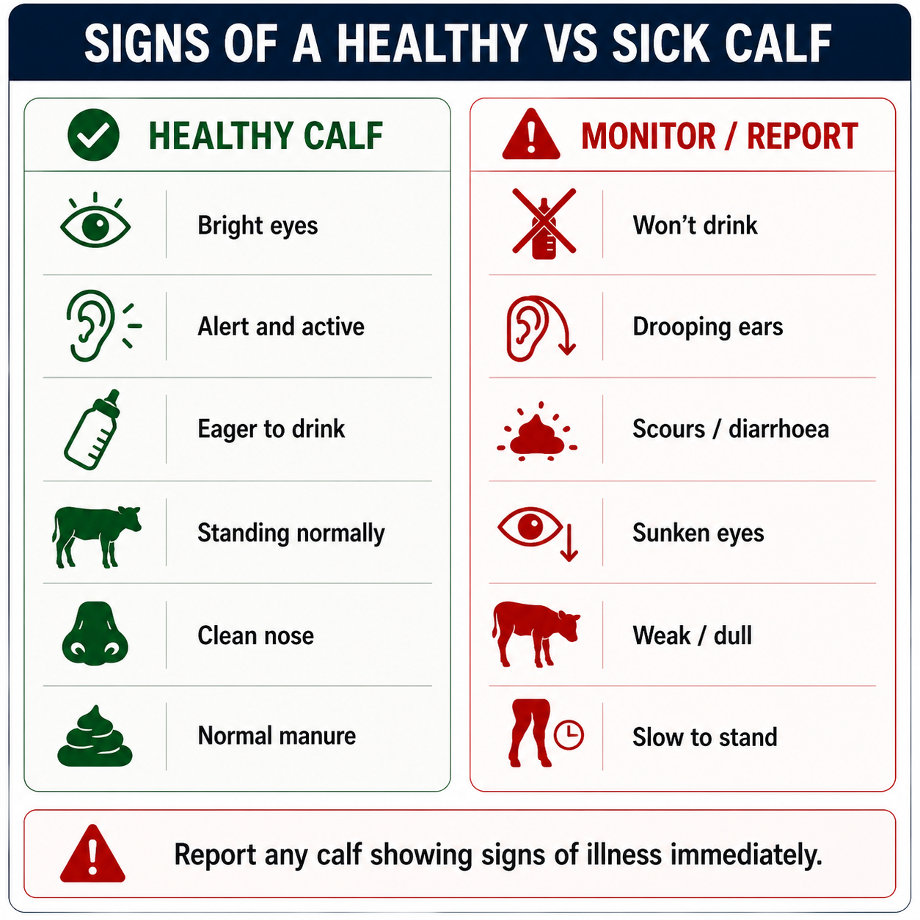
2 | Prepare the milk  Use fresh, clean milk or milk replacer prepared according to farm instructions. Mix thoroughly and check the temperature.  When mixing milk replacer, measure the amounts of powder and water accurately. Even small changes in the concentration of the milk can cause digestive problems.  Avoid being too prescriptive about milk temperature. Consistency of temperature at each feed is more important than a specific temperature. In warmer environments, milk may not need to be warmed, whereas in colder conditions, warming may be appropriate. | Maintain consistent milk concentration and temperature at each feed.  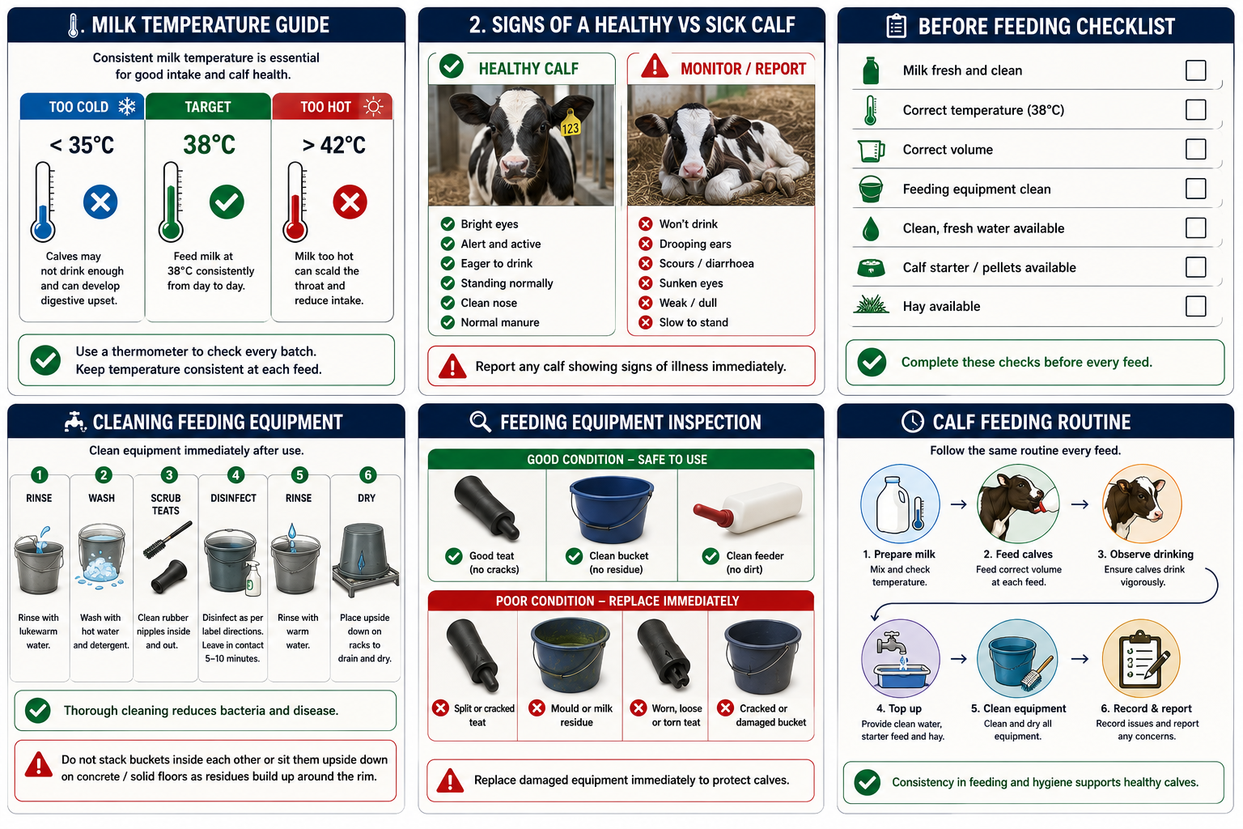
3 | Check feeding equipment  Inspect buckets, feeders, tubes and teats to ensure they are clean and free from old milk, mould, dirt or faecal contamination. | Replace cracked, damaged or worn teats.
4 | Good Hygiene  Wash your hands before handling milk or feeding equipment. Use clean buckets, teats and feeders, feed only fresh milk, and keep feeding equipment off the ground. Separate sick calves from healthy calves where possible and avoid using dirty or damaged equipment. | Good hygiene helps reduce the spread of disease and supports healthy calf growth.  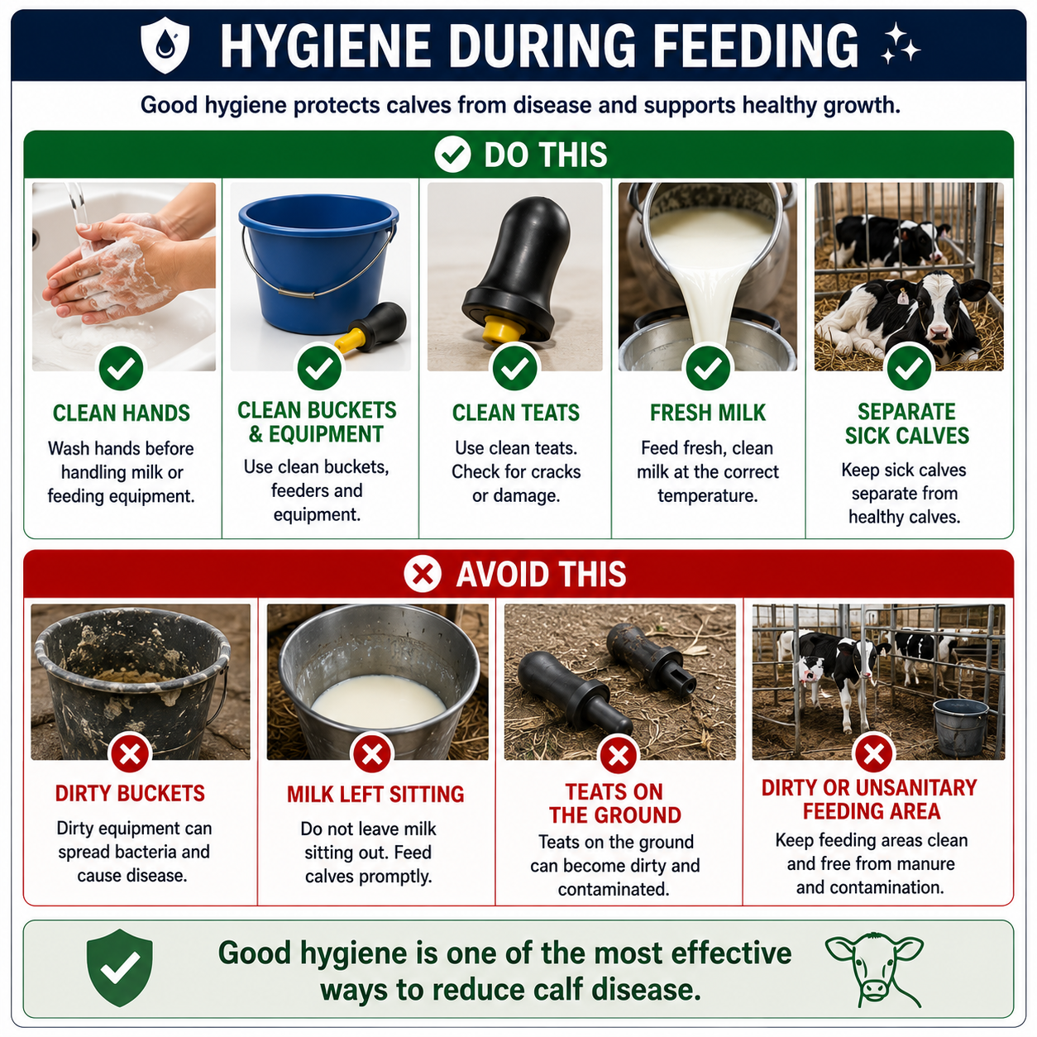
4 | Feed the correct amount  Feed each calf group the farm-specified volume and number of feeds per day. | Do not overfeed or change feeding volumes without approval.
5 | Monitor drinking  Watch calves while feeding and note any calf that drinks slowly, does not finish or fails to suck vigorously. | Seek assistance if a calf will not drink or appears unwell.
6 | Manage calf groups  Ensure calves can access the feeder without being pushed away or outcompeted by larger calves. | Group calves appropriately by size, age and feeding needs.
7 | Provide water and solid feed  Ensure calves have continuous access to clean, fresh water and top up calf starter, pellets and hay as required. | Remove wet, stale or contaminated feed.
8 | Clean  Rinse, wash, disinfect and dry all feeding equipment immediately after use. | Thorough cleaning reduces bacterial contamination and disease risk.
9 | Record and report  Record feeding issues and report calves with poor intake, illness or abnormal behaviour. | Early action supports calf health and recovery.
SPILLS, EXPOSURE AND EMERGENCIES
! | EMERGENCY: If a calf becomes distressed, collapses, chokes or shows signs of severe illness, stop feeding and notify the farm owner or manager immediately. Seek veterinary assistance where required.
DISPOSAL AND ENVIRONMENTAL PROTECTION
Hygiene | Wash hands before handling milk, wear clean gloves. Clean and sanitise all buckets, bottles and teats. Ensure boots and clothes are clean before entering calf areas.
Disposal | Dispose of spoiled milk, feed waste and cleaning solutions according to farm procedures. Prevent milk, chemicals and wastewater from entering waterways or stormwater drains.
FARM-SPECIFIC DETAILS
! | IMPORTANT: Complete these details before this SOP is issued to workers.
Milk type
Milk volume per feed
Feeds per day
Required milk temperature
Calf groups
Milk replacer mixing rate
Approved detergent/disinfectant
Emergency contact / farm manager

Disclaimer
Dairy Australia provides this template as general guidance only. Farm businesses are responsible for reviewing, customising and implementing this SOP to suit their own workplace, equipment, hazards and legal obligations. Users should ensure this SOP reflects current legislation, manufacturer instructions, product labels and Safety Data Sheets (SDS) relevant to their business.

