DAIRY MAINTENANCE
Routine inspection, cleaning and maintenance of dairy equipment to ensure safe, efficient operation and maintain milk quality.
SOP NUMBER | VERSION | APPROVED BY | NEXT REVIEW | FARM / BUSINESS NAME
SOP-009 | 1.0
📝 Template Note: This Standard Operating Procedure (SOP) is provided as a template only. It must be reviewed and adapted to reflect your farm business.

PURPOSE AND SCOPE
Purpose  To ensure the dairy is routinely inspected, cleaned and maintained to maximise equipment performance, minimise breakdowns and support milk quality and animal welfare. | Scope  This SOP applies to all authorised employees responsible for carrying out routine dairy maintenance and inspections.
BEFORE YOU START
PPE  Wear appropriate PPE, including steel cap boots, gloves, eye protection and hearing protection where required. Ensure clothing is suitable for working around machinery and moving equipment. | EQUIPMENT AND DOCUMENTATION  Ensure the required cleaning equipment, lubricants, replacement parts and maintenance tools are available before commencing work. Record any maintenance completed in the farm maintenance log. | PREPARATION  Confirm the dairy is safe to enter, isolate equipment where required and report any major faults that require contractor attention before starting maintenance.

! | WARNING: Always isolate machinery before carrying out maintenance. Never work on moving equipment or electrical components unless authorised and trained.
PROCEDURE
STEP | WHAT TO DO | SAFETY / QUALITY / ENVIRONMENT
1 | Inspect the dairy  Conduct a visual inspection of the dairy, checking for damage, leaks, unusual noises or maintenance issues. | Early identification helps prevent breakdowns.  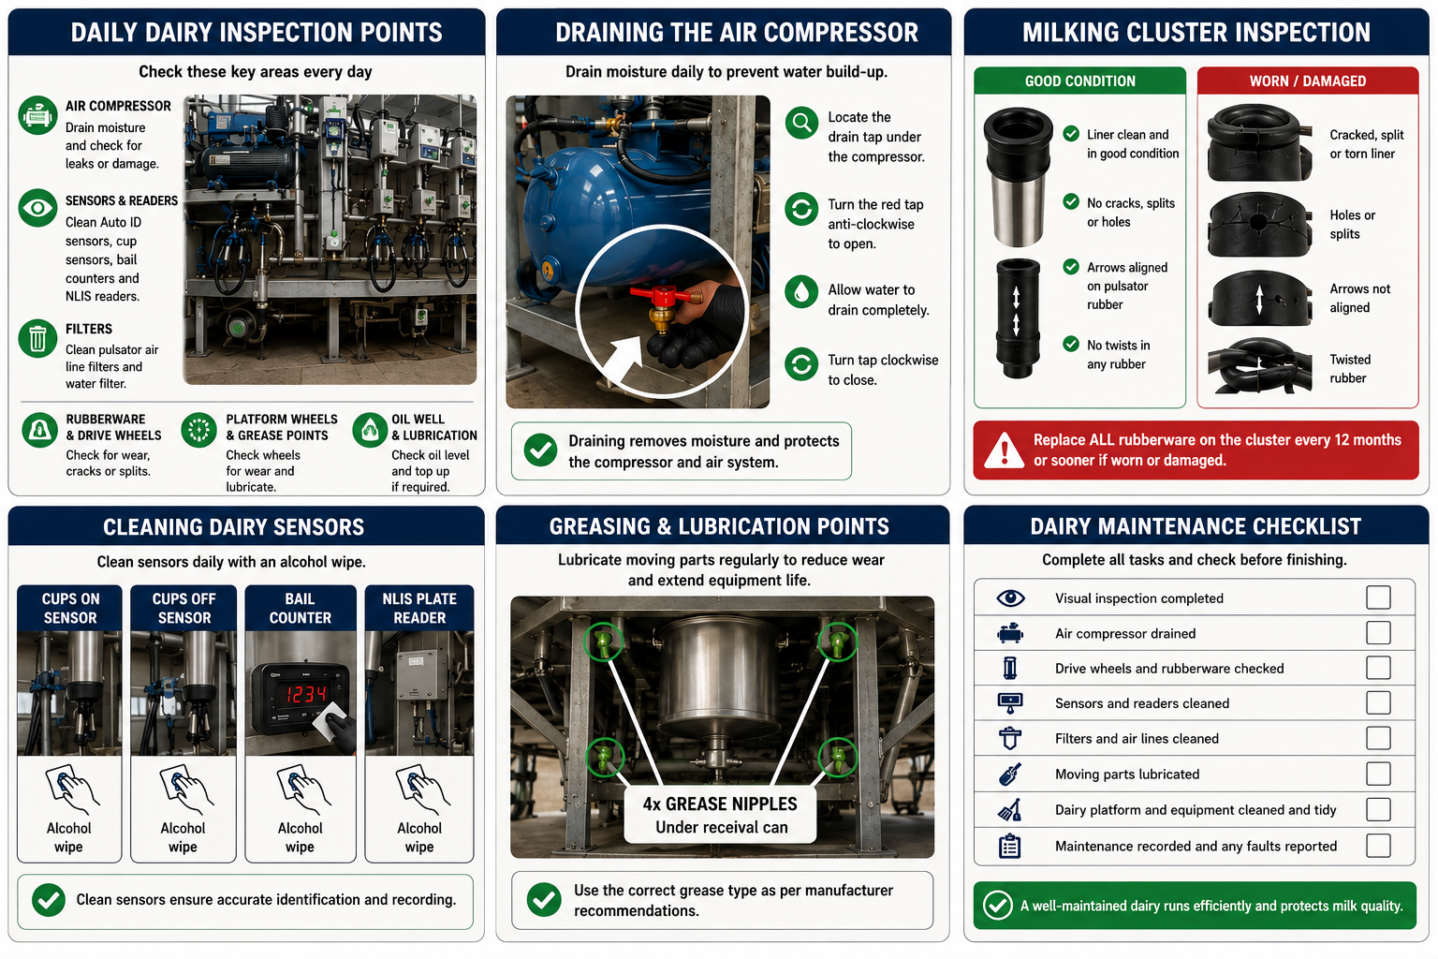
2 | Drain the air compressor  Drain moisture from the air compressor using the drain tap to prevent water build-up. | Moisture can reduce compressor performance and damage equipment.
3 | Inspect drive wheels and rubberware  Check drive wheels, liners and rubber components for wear, cracks, splits or damage. Replace worn rubberware in accordance with the maintenance schedule. | Worn rubberware affects milking performance and milk quality.
4 | Clean sensors and readers  Clean Auto ID sensors, cup sensors, bail counters and NLIS plate readers using an approved cleaning wipe or cloth. | Dirty sensors can reduce system accuracy.
5 | Clean filters and air lines  Clean pulsator air line filters, water filters and filter sock taps to maintain airflow and water quality. | Blocked filters reduce equipment efficiency.
6 | Lubricate moving components  Grease and lubricate moving parts, including platform wheels and grease points, in accordance with manufacturer recommendations. | Correct lubrication extends equipment life.
7 | Clean the dairy  Hose down the dairy platform, tidy work areas, clean stainless-steel equipment, empty bins and complete the dairy plant wash. | Maintaining cleanliness supports milk quality and biosecurity.
8 | Record and report maintenance  Record completed maintenance, identify any defects requiring repair and report contractor servicing requirements to the farm owner or manager. | Accurate records assist preventative maintenance planning.
SPILLS, EXPOSURE AND EMERGENCIES
! | EMERGENCY: If equipment becomes unsafe or a fault is identified, stop work, isolate the equipment where safe to do so and notify the farm owner or manager immediately. Contact emergency services (000) if required.
DISPOSAL AND ENVIRONMENTAL PROTECTION
Waste | Dispose of waste, used filters, cleaning materials and lubricants in accordance with farm procedures. Prevent oils, chemicals and contaminants from entering drains or waterways, and report any spills immediately.
FARM-SPECIFIC DETAILS
! | IMPORTANT: Complete these details before this SOP is issued to workers.
Maintenance schedule
Replacement rubberware interval
Grease type
Approved Cleaning products
Contract service provider
Emergency contact / farm manager

Disclaimer
Dairy Australia provides this template as general guidance only. Farm businesses are responsible for reviewing, customising and implementing this SOP to suit their own workplace, equipment, hazards and legal obligations. Users should ensure this SOP reflects current legislation, manufacturer instructions, product labels and Safety Data Sheets (SDS) relevant to their business.

