CONTRACTOR INDUCTION - SILAGE
Safety, communication and operational requirements for all contractors involved in silage operations.
SOP NUMBER | VERSION | APPROVED BY | NEXT REVIEW | FARM / BUSINESS NAME
SOP-007 | 1.0
📝 Template Note: This Standard Operating Procedure (SOP) is provided as a template only. It must be reviewed and adapted to reflect your farm business.

PURPOSE AND SCOPE
Purpose  To ensure all contractors understand the farm's safety requirements, site hazards, communication procedures and operational expectations before undertaking silage operations. | Scope  Applies to all contractors, subcontractors, visitors and workers involved in silage harvesting, transport and stack operations on the farm.
BEFORE YOU START
PPE  Hi-vis clothing, Steel cap boots, Hearing protection, Safety glasses, Gloves, Weather appropriate clothing | EQUIPMENT  UHF Radio, Mobile phone, Vehicle in safe condition, Fire extinguisher, First aid kit | PREPARATION  Attend toolbox meeting, Read this induction, Complete Contractor Details Form, Sign induction record, Confirm UHF channel, Understand emergency procedures

! | WARNING: Silage harvesting involves multiple large machines operating simultaneously. Never assume another operator has seen you.
PROCEDURE
STEP | WHAT TO DO | SAFETY / QUALITY / ENVIRONMENT
1 | Attend the toolbox meeting  Attend the pre-start meeting conducted by the farm manager and contractor supervisor. Review paddocks, weather, hazards, work sequence, emergency contacts and UHF channel. | Every contractor must sign the induction register before commencing work.
2 | PPE  Hi-vis clothing, Steel cap boots, Hearing protection, Safety glasses, Gloves, Weather appropriate clothing | 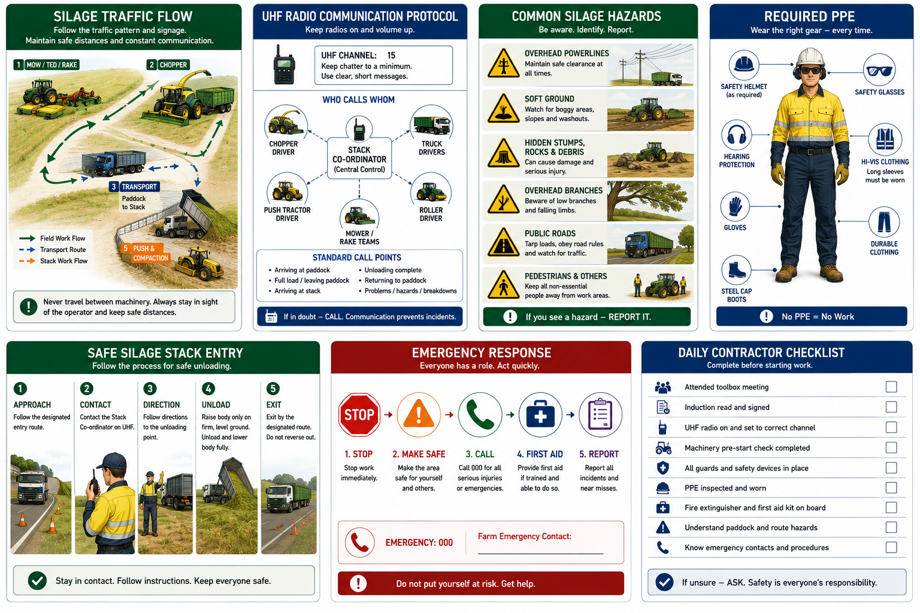
2 | Inspect machinery  Complete pre-start checks on tractors, trucks, trailers and implements. Ensure guards, lights, brakes, mirrors, tyres and safety devices are operational. | Remove defective machinery from service until repaired.
3 | Mowing, tedding and raking  Follow the agreed harvesting sequence. Adjust mower settings to suit crop conditions. Inspect blades regularly and remove hazards where safe to do so. | Watch for rocks, wire, tree stumps, irrigation equipment and hidden obstacles.
4 | Chopping and loading  Follow the chopper driver's instructions. Maintain safe separation distances and communicate movements via UHF. | If terrain becomes unsafe, withdraw and notify the chopper operator immediately.
5 | Travelling between paddock and stack  Tarp loads before travelling on public roads. Obey road rules and use designated transport routes. | Drive to road and weather conditions. Watch for school buses, livestock and other road users.
6 | Unloading at the silage stack  Contact the stack coordinator before entering. Follow directions for unloading. Raise the body only on firm, level ground. | Be aware of overhead powerlines and other machinery. Never reverse suddenly to free a load.
7 | Stack construction  Push and roller tractors maintain stack shape and compaction. Maintain communication at all times. | Seat belts must be worn. Use experienced operators only.
8 | End of shift  Park machinery safely, report incidents, hazards or maintenance requirements and attend end-of-day debrief if required. | Ensure all equipment is secured before leaving site.
SPILLS, EXPOSURE AND EMERGENCIES
! | EMERGENCY:  - Stop work immediately if an unsafe situation develops.  - Notify all operators via UHF radio.  - Contact the site coordinator.  - Call 000 for serious injury or life-threatening emergencies.  - Keep access clear for emergency vehicles.  - Report all incidents and near misses before leaving site.
SITE RULES
- No mobile phone use while driving.
- No alcohol or drugs.
- Wear seat belts.
- Follow speed limits.
- Obey all farm signs.
- Report hazards immediately.
- Visitors only with approval.
FARM-SPECIFIC DETAILS
! | IMPORTANT: Complete these details before this SOP is issued to workers.
UHF Channel
Emergency Assembly Point
First Aid Location
Nearest Hospital
Property Reference Map
Emergency contact / farm manager

Disclaimer
Dairy Australia provides this template as general guidance only. Farm businesses are responsible for reviewing, customising and implementing this SOP to suit their own workplace, equipment, hazards and legal obligations. Users should ensure this SOP reflects current legislation, manufacturer instructions, product labels and Safety Data Sheets (SDS) relevant to their business.

