COLOSTRUM MANAGEMENT FOR FEEDING NEWBORN CALVES
Collection, testing, storage and feeding of high-quality colostrum.
SOP NUMBER | VERSION | APPROVED BY | NEXT REVIEW | FARM / BUSINESS NAME
SOP-006 | 1.0
📝 Template Note: This Standard Operating Procedure (SOP) is provided as a template only. It must be reviewed and adapted to reflect your farm business.

PURPOSE AND SCOPE
Purpose  Disposable gloves, Waterproof boots, Clean protective clothing. | Scope  Applies to workers collecting, testing, storing and feeding colostrum.
BEFORE YOU START
PPE  Wear PPE specified on the label and SDS. | EQUIPMENT  Clean collection bucket, Brix refractometer, Feeding bottle and teat, Oesophageal feeder (trained staff only), Refrigerator, Freezer, Water bath, Permanent marker and storage bags. | PREPARATION  Ensure all equipment is clean and sanitised, Check feeding equipment is assembled correctly, Prepare clean storage containers, Confirm fresh cows are available for collection. | TIP  Freeze excess high-quality colostrum in flat bags so it thaws quickly.

! | WARNING: Never feed colostrum from cows under antibiotic withholding periods or cows showing signs of mastitis or bloody milk.
PROCEDURE
STEP | WHAT TO DO | SAFETY / QUALITY / ENVIRONMENT
1 | Collect  Clean, disinfect and dry teats prior to harvesting colostrum. Collect first-milking colostrum from freshly calved cows using clean equipment. Check the cow for mastitis before collection. | Never use milk from antibiotic withholding cows or blood-stained colostrum. Discard colostrum from cows that are sick or suspected of being positive for disease such as Johne’s disease, Salmonellosis or Mycoplasma.
2 | Test  Test every batch using a calibrated Brix refractometer.  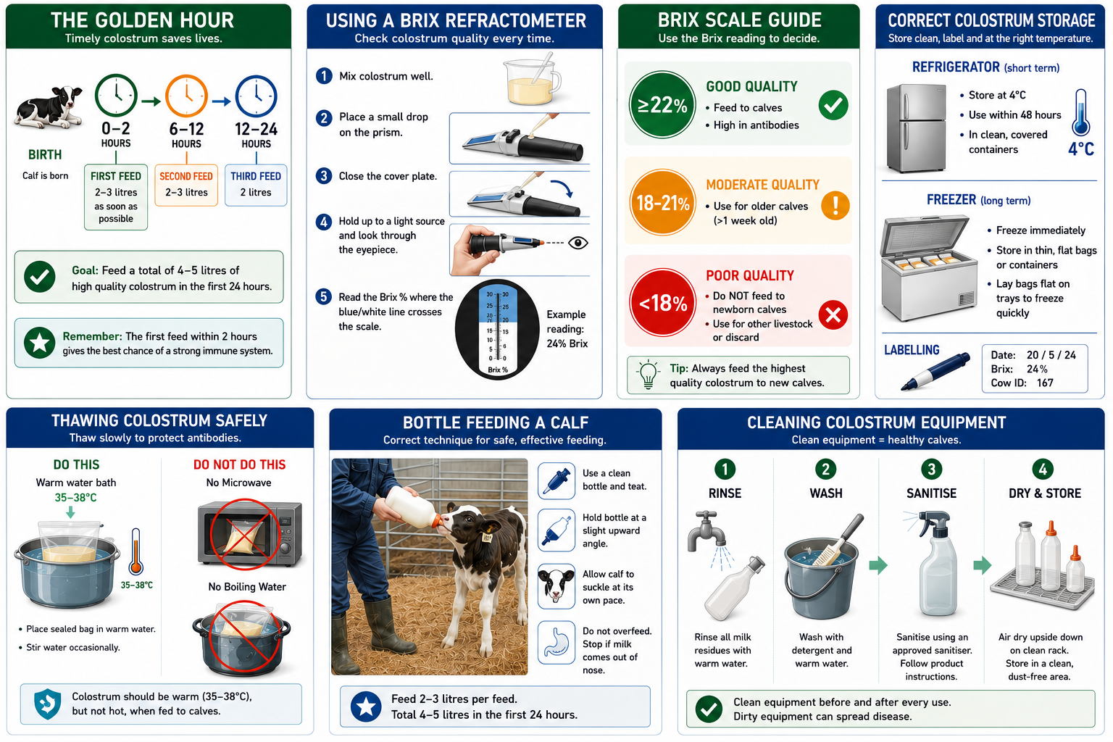 | Only feed colostrum with a Brix reading of 22% or greater.
3 | Label  Label all stored colostrum with the collection date and Brix reading. | Do not mix colostrum from different cows.
4 | Store  Store unused colostrum correctly. Refrigerate at 4°C for up to 48 hours or freeze immediately for long-term storage. | Store in clean, sealed containers or freezer bags.
5 | Thaw  Thaw frozen colostrum slowly in a warm water bath (35–38°C). | Never use boiling water or a microwave as this damages antibodies.
6 | Feed  Feed calves 2–3 litres as soon as possible after birth (preferably within 2 hours), followed by a second feed within the first 12 hours and an additional feed during the next 12 hours to achieve 4–5 litres in the first 24 hours. Do not feed colostrum if blood or clots are present. | Ensure feeding equipment is clean before every use.
7 | Trouble feeding  If the calf cannot suckle effectively, use an oesophageal feeder only if trained and competent. | Seek assistance if you are not trained in stomach tubing.
8 | Clean  Wash, sanitise and dry all feeding equipment immediately after use. | Dirty equipment is one of the largest causes of bacterial contamination in colostrum.
SPILLS, EXPOSURE AND EMERGENCIES
! | EMERGENCY: Stop feeding immediately if the calf shows signs of aspiration or distress. Seek veterinary advice if a calf refuses multiple feeds or appears weak. Report any contaminated colostrum or equipment failures. Provide first aid for worker injuries. Call 000 in the event of a life-threatening emergency.
DISPOSAL AND ENVIRONMENTAL PROTECTION
Hygiene | Wash hands before handling colostrum, wear clean gloves. Clean and sanitise all buckets, bottles and teats. Clean boots before entering calf rearing areas. Dispose of spoiled colostrum appropriately.
FARM-SPECIFIC DETAILS
! | IMPORTANT: Complete these details before this SOP is issued to workers.
Minimum Brix reading
Storage location
Refrigerator temperature
Feeding schedule
Approved disinfectant
Emergency contact / farm manager

Disclaimer
Dairy Australia provides this template as general guidance only. Farm businesses are responsible for reviewing, customising and implementing this SOP to suit their own workplace, equipment, hazards and legal obligations. Users should ensure this SOP reflects current legislation, manufacturer instructions, product labels and Safety Data Sheets (SDS) relevant to their business.

