CHAINSAW USE
Safe operation of chainsaws for farm maintenance activities.
SOP NUMBER | VERSION | APPROVED BY | NEXT REVIEW | FARM / BUSINESS NAME
SOP-005 | 1.0
📝 Template Note: This Standard Operating Procedure (SOP) is provided as a template only. It must be reviewed and adapted to reflect your farm business.

PURPOSE AND SCOPE
Purpose  To ensure chainsaws are operated safely and correctly to minimise injury, equipment damage and environmental harm. | Scope  Applies to authorised and trained workers using chainsaws for farm maintenance.
BEFORE YOU START
PPE  Helmet with face shield, hearing protection, chainsaw chaps, gloves, steel-capped boots and fitted clothing. | EQUIPMENT  Chainsaw, fuel, chain oil, first aid kit, communication device. | PREPARATION  Inspect work area, identify hazards, notify another worker, and complete all pre-start checks.

! | WARNING: Never operate a chainsaw without appropriate training or authorisation.
PROCEDURE
STEP | WHAT TO DO | SAFETY / QUALITY / ENVIRONMENT
1 | Inspect  Before use, inspect the chainsaw for damage, loose or missing parts, fuel leaks, chain sharpness, correct chain tension, chain lubrication, throttle lock, chain brake and chain catcher. Ensure all safety devices are functioning correctly. | Do not use a damaged or defective chainsaw. Report faults immediately and remove the saw from service until repaired.  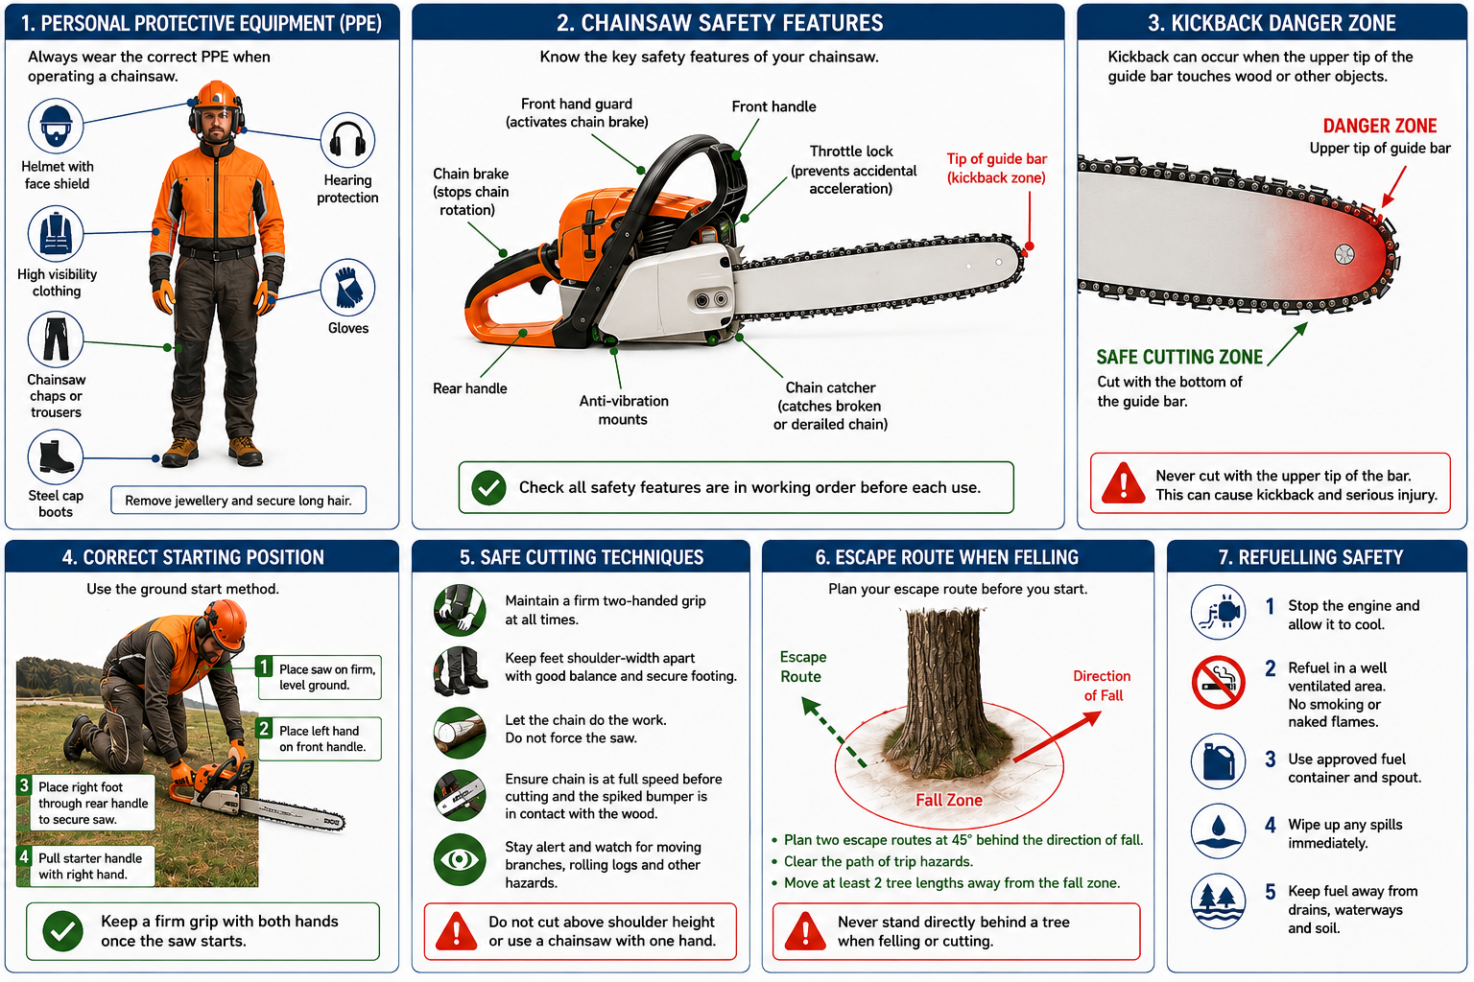
2 | Prepare  Put on all required PPE. Inspect the work area for trip hazards, overhead hazards, powerlines, unstable trees, loose branches, rocks and bystanders. Establish an exclusion zone and identify at least one safe escape route. | Never operate a chainsaw alone unless another person knows your location and expected return time. Keep all other people at least two tree lengths away from the work area.
3 | Start the chainsaw  Place the chainsaw on firm, level ground. Engage the chain brake. Hold the front handle firmly with your left hand, place your right foot through the rear handle and start the engine following the manufacturer's instructions. Allow the engine to warm up before cutting. | Never drop-start a chainsaw. Always use the ground-start method recommended by the manufacturer.
4 | Operate correctly  Hold the chainsaw firmly with both hands, keeping your thumbs wrapped around the handles. Maintain a balanced stance with secure footing. Cut only at waist height or below where practical. | Never operate the saw one-handed. Never cut above shoulder height. Remain alert for kickback and changing conditions.
5 | Cut safely  Bring the chain to full operating speed before contacting the timber. Use the bumper spikes to stabilise the saw where appropriate. Allow the saw to cut at its own pace without forcing it through the timber. Watch for movement in branches, rolling logs and timber under tension or compression. | Avoid using the upper tip of the guide bar (kickback zone). Stop immediately if the timber shifts unexpectedly.
6 | Pause work safely  Whenever walking between cuts or repositioning, engage the chain brake. Stop the engine before carrying the chainsaw over uneven ground or long distances. | Never walk with the chain rotating. Carry the saw with the guide bar pointing behind you and the muffler away from your body
7 | Refuel Safely  Turn the engine off and allow it to cool before refuelling. Refuel in a well-ventilated area away from ignition sources. Use approved fuel containers and avoid overfilling. Clean up any spills immediately. | Never refuel a hot or running chainsaw. Prevent fuel from entering drains, waterways or soil.
8 | Shutdown  After use, clean the chainsaw, remove sawdust and debris, inspect the guide bar and chain, sharpen the chain if required, top up chain oil and report any faults. Fit the chain guard and store the chainsaw in its designated secure location. | A clean and well-maintained chainsaw is safer, performs better and extends equipment life. Record any maintenance or repairs required.
Checklist - Before Cutting
Before making the first cut, confirm that:
- The work area has been inspected – Escape route identified and no people in exclusion zone.
- PPE is being worn correctly.
- Chain brake and controls have been tested.
- Chain tension and lubrication are correct.
- Timber has been assessed for tension and compression.
- Weather conditions are suitable.
- First aid kit and communication device are available.
SKILLS, EXPOSURE AND EMERGENCIES
! | EMERGENCY: Provide first aid and call 000 for serious injury. Contains and report fuel spills.
DISPOSAL AND ENVIRONMENTAL PROTECTION
Remove waste | Remove debris after use.
Storage | Store safely and report faults
FARM-SPECIFIC DETAILS
! | IMPORTANT: Complete these details before this SOP is issued to workers.
Authorised operators
Storage location
Fuel storage
Maintenance schedule
Emergency contact / farm manager

Disclaimer
Dairy Australia provides this template as general guidance only. Farm businesses are responsible for reviewing, customising and implementing this SOP to suit their own workplace, equipment, hazards and legal obligations. Users should ensure this SOP reflects current legislation, manufacturer instructions, product labels and Safety Data Sheets (SDS) relevant to their business.

