TAGGING AND REMOVING CALVES
Safe collection, identification and transport of newborn calves.
SOP NUMBER | VERSION | APPROVED BY | NEXT REVIEW | FARM / BUSINESS NAME
SOP-004 | 1.0
📝 Template Note: This Standard Operating Procedure (SOP) is provided as a template only. It must be reviewed and adapted to reflect your farm business.

PURPOSE AND SCOPE
Purpose  To ensure newborn calves are safely identified, tagged, recorded and transported while protecting worker safety, animal welfare and biosecurity. | Scope  Applies to workers identifying freshly calved cows, collecting calves, tagging, recording identification details and transporting calves to the calf-rearing area.
BEFORE YOU START
PPE  Disposable gloves, waterproof boots, suitable clothing and eye protection where required. | EQUIPMENT  Clean calf trailer, ATV/vehicle, tag applicator, NLIS tags, farm tags, neck tags, iodine spray, calf jackets and recording sheet. | PREPARATION  Ensure equipment is clean, trailer disinfected and calf records are available. | TIP  Use two people to lift calves where practical.

! | WARNING: Freshly calved cows can be highly protective. Maintain a safe escape route.
PROCEDURE
STEP | WHAT TO DO | SAFETY / QUALITY / ENVIRONMENT
1 | Prepare  Identify the freshly calved cow and calf. Record the cow ID and calving date. | Stay outside the cow's flight zone until identification is complete.
2 | Approach  Approach the calf while monitoring the cow. Position the trailer close to minimise carrying distance. | Use the ATV or trailer as a barrier if required.
3 | Lift safely  Lift the calf safely into the trailer using correct manual handling. | 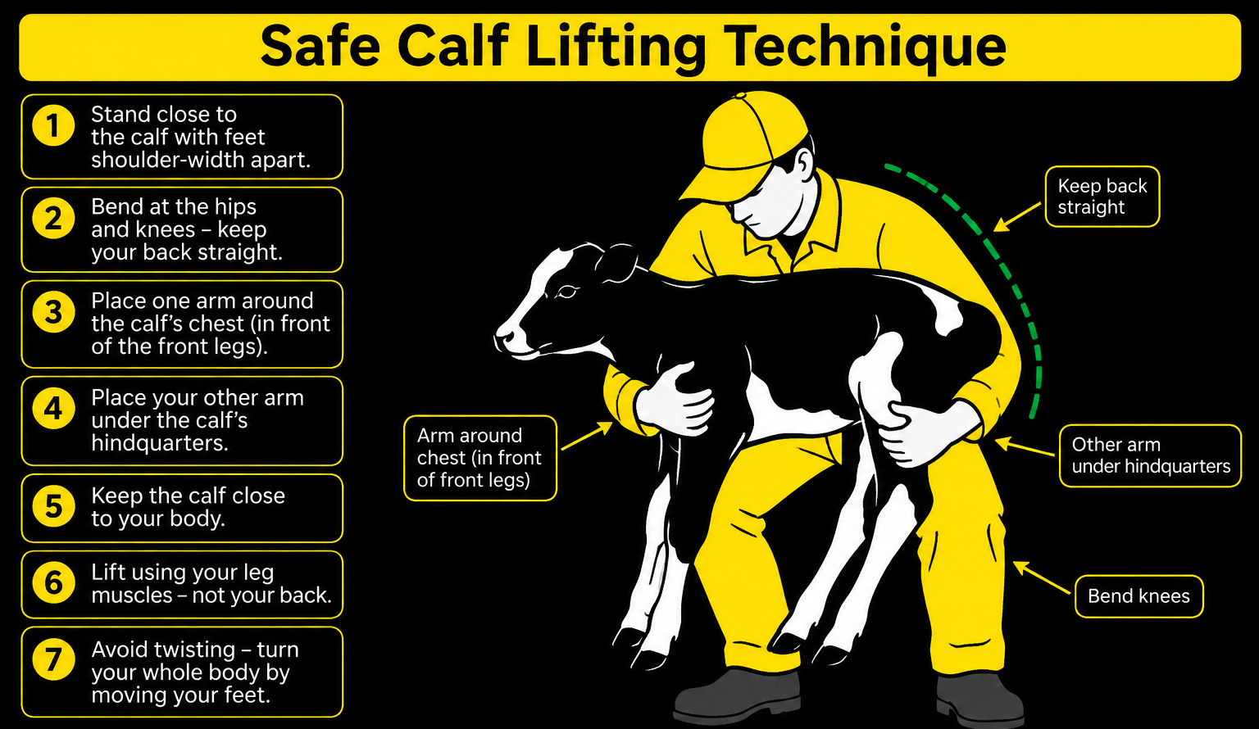Use two people whenever practical.
4 | Record details  Record calf details including sex, cow ID and calf number. | Accurate records support herd management and genetics.
5 | Apply tags  Apply identification tags. Bull calves receive the NLIS tag in the right ear. Heifer calves receive farm tags in both ears and neck identification as required. | Place tags in the centre of the ear.  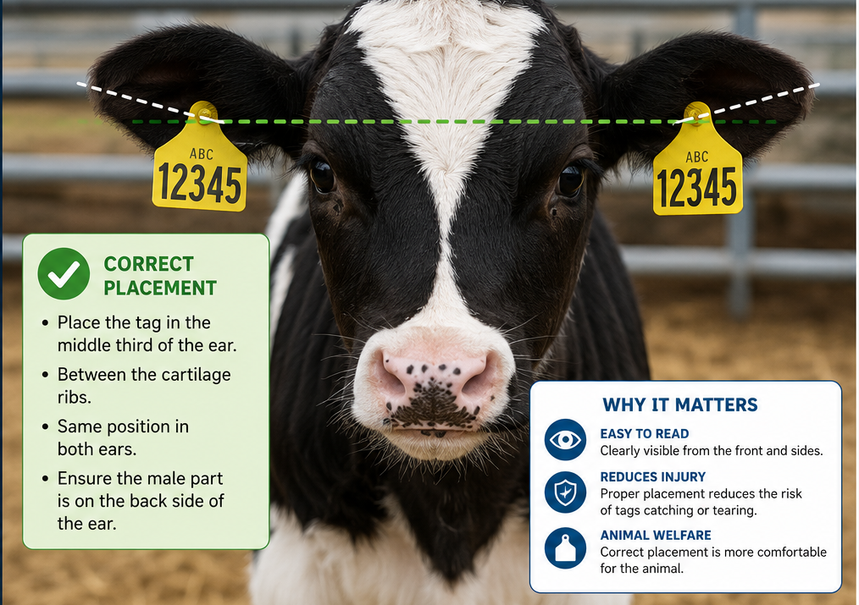
6 | Spray  Spray ear tag sites and umbilical cord with iodine. | Reduce infection risk.
7 | Transport  Transport calves carefully to the calf-rearing area and follow the Colostrum Feeding SOP. Transport calves directly from the calving paddock to the calf shed- avoid transiting through areas contaminated by manure such as dairy yards. | Drive slowly and avoid sudden movements.
8 | Clean  Clean and disinfect the calf trailer, tag applicator and equipment. | Maintain biosecurity.
SPILLS, EXPOSURE AND EMERGENCIES
! | EMERGENCY: If the cow becomes aggressive, stop work and move to a safe location. Provide first aid for injuries and notify the supervisor. Seek veterinary assistance if a calf is injured or distressed. Call 000 for life-threatening emergencies.
DISPOSAL AND ENVIRONMENTAL PROTECTION
Hygiene | Clean and disinfect equipment, dispose of gloves and wash hands.
Biosecurity | Follow farm biosecurity and zoonotic disease procedures.
FARM-SPECIFIC DETAILS
! | IMPORTANT: Complete these details before this SOP is issued to workers.
Calving recording system
Approved iodine
Tag numbering system
Colostrum area
Emergency contact / farm manager

Disclaimer
Dairy Australia provides this template as general guidance only. Farm businesses are responsible for reviewing, customising and implementing this SOP to suit their own workplace, equipment, hazards and legal obligations. Users should ensure this SOP reflects current legislation, manufacturer instructions, product labels and Safety Data Sheets (SDS) relevant to their business.

