CALF REARING GENOMIC TESTING
Collecting samples for genomic testing using Tissue Sampling Units (TSUs)
SOP NUMBER | VERSION | APPROVED BY | NEXT REVIEW | FARM / BUSINESS NAME
SOP-002 | 1.0
📝 Template Note: This Standard Operating Procedure (SOP) is provided as a template only. It must be reviewed and adapted to reflect your farm business.

PURPOSE AND SCOPE
Purpose  To ensure tissue samples are collected safely and accurately for reliable genomic testing. | Scope  Applies to all workers collecting tissue samples from calves using TSUs.
BEFORE YOU START
PPE  Disposable gloves, sturdy waterproof boots. | EQUIPMENT  TSUs, applicator, recording sheet, pen, waste bin. | PREPARATION  Confirm calf ID and ensure applicator is clean. | TIP  Collect samples during disbudding where possible while calves are already restrained.

! | WARNING: Incorrect calf identification or poor sampling may produce invalid genomic results.
PROCEDURE
STEP | WHAT TO DO | SAFETY / QUALITY / ENVIRONMENT/IMAGE
1 | Prepare  Gather TSUs, applicator, pen and sharps bin. | 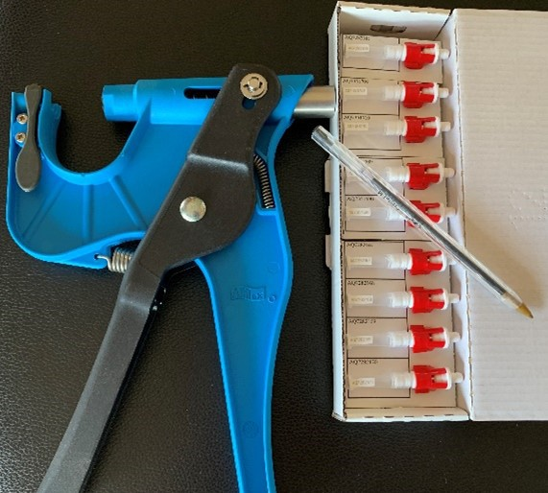
2 | Wear PPE  Disposable gloves, sturdy waterproof boots. | Replace damaged PPE.
3 | Load applicator  Insert TSU and charge the applicator following manufacturer instructions. | 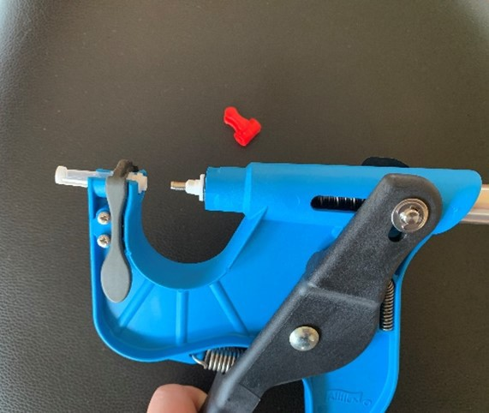
4 | Restrain calf  Use an appropriate restraint method for the calf's age. | 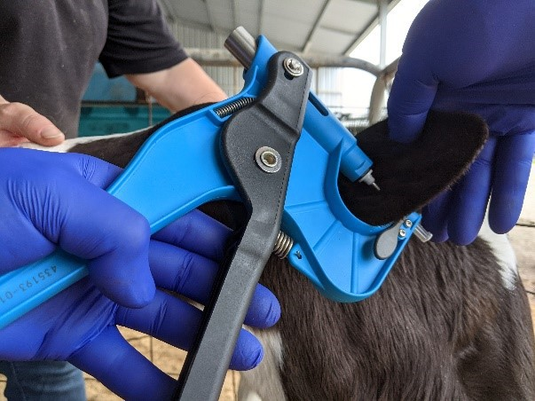
5 | Collect Sample  Take sample 1–2 cm from the ear edge, avoiding cartilage and major blood vessels.  Safely dispose of needle in sharps bin  Keep fingers clear of the needle in the pliers when taking the sample and disposing the needle. | 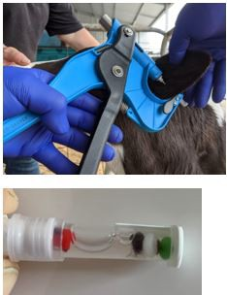  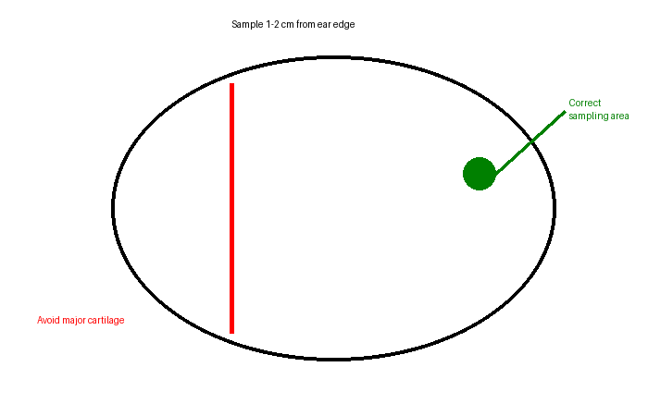
6 | Record sample  Immediately match calf ID to TSU number.  Clear and accurate recording of calf ID next to TSU sample number is crucial to a successful result  Store TSUs at room temperature. Submit samples soon after collection. | 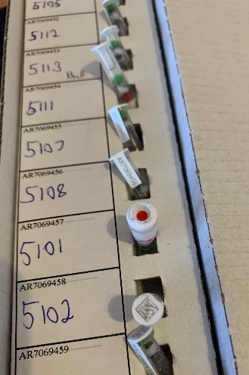
7 | Clean up  Clean applicator, dispose of waste, wash hands.
SPILLS, EXPOSURE AND EMERGENCIES
! | EMERGENCY: Call 000 for serious injury. If injury occurs, stop task immediately and seek first aid. If exposure to blood or body fluids occurs, wash skin and flush eyes, seek medical advice if needed. Follow incident reporting procedures.

OTHER INFORMATION
🟢 QUALITY CHECK | Always confirm the tissue sample and green bead are visible inside the TSU before storing.
🟠 COMMON MISTAKE: | Recording the wrong calf ID against the TSU number.

FARM-SPECIFIC DETAILS
! | IMPORTANT: Complete these details before this SOP is issued to workers.
Sample storage location
Recording system
Laboratory/ courier
Emergency contact / farm manager

Disclaimer
Dairy Australia provides this template as general guidance only. Farm businesses are responsible for reviewing, customising and implementing this SOP to suit their own workplace, equipment, hazards and legal obligations. Users should ensure this SOP reflects current legislation, manufacturer instructions, product labels and Safety Data Sheets (SDS) relevant to their business.

